A

MAJOR PROJECT-III REPORT

on

GCM Multi Model Ensemble Prediction

Submittedby:

Bhawna (220662)

Bhumika (220661)

Ruchi Verma (220618)

under mentorship of

Dr. Kiran Khatter

(Professor)



Department of Computer Science Engineering

School of Engineering and Technology

BML MUNJAL UNIVERSITY, GURUGRAM (INDIA)

May 2025

**INDEX**

|  |  |  |
| --- | --- | --- |
| **Serial No.** | **Topic** | **Page No.** |
| 1 | Candidates Declaration and Supervisors Declaration | 3 |
| 2 | Abstract | 4 |
| 2 | Acknowledgement | 5 |
| 3 | List of Figures | 6 |
| 4 | List of Tables | 7 |
| 5 | Abbreviation | 8 |
| 6 | Introduction | 9 |
| 7 | Literature Review | 13 |
| 8 | Exploratory Data Analysis | 18 |
| 9 | Methodology | 24 |
| 10 | Results | 40 |
| 11 | Conclusion | 56 |
| 12 | References | 58 |

**CANDIDATE’S DECLARATION**

**___________________________________________________**

I hereby certify that the work on the project entitled, “**GCM Multi Model Ensemble Prediction**”, in partial fulfillment of requirements for the award of Degree of **Bachelor of Technology** in School of Engineering and Technology at BML Munjal University, having University Roll No.1232434, is an authentic record of my own work carried out during a period from January 2025 to July 2025 under the supervision of **Dr. Kiran Khatter.**

## Bhawna

## Bhumika

## Ruchi Verma

**SUPERVISOR’S DECLARATION**

**____________________________________________________**

This is to certify that the above statement made by the candidate is correct to the best of my knowledge.

**Faculty Supervisor Name: Dr. Kiran Khatter**

**Signature:**

**ABSTRACT**

Climate change remains one of the most daunting global challenges, requiring highly precise and reliable climate predictions to guide policy choices, disaster risk management, and long-term resource planning. Although Global Climate Models (GCMs) continue to be at the core of future climate projections, their results tend to differ significantly because of structural, physical, and parametric uncertainties. To overcome these deficiencies, this research introduces a comparative modeling approach aimed at improving regional precipitation prediction over India.

In the first methodology, a deep learning model is constructed based on a Long Short-Term Memory (LSTM) and is trained on multi-GCM precipitation data, observational high-resolution India Meteorological Department (IMD) data, and neutrosophic-derived metrics: Truth, Indeterminacy, and Falsity (TIF). Seasonal features like monthly climatology, lagged values of precipitation, and monsoon phase indicators are directly incorporated as input features to allow the LSTM to learn intra-annual cyclical behavior as well as long-term trends. This merging enables the model to acquire sophisticated spatiotemporal dependencies and uncertainties in climate projections.

The second method introduces a new ensemble scheme that averages GCM outputs with a neutrosophic logic-based weighting scheme, with each model contribution evaluated along TIF dimensions. These weights, as well as the neutrosophic hyperparameters, are optimized simultaneously by Particle Swarm Optimization (PSO). The PSO algorithm is effective in exploring the solution space to find an optimal ensemble configuration that improves prediction consistency and accuracy.

Both frameworks are strictly tested with performance metrics like RMSE, MAE, correlation coefficient, and skill scores, and results are compared against IMD observations. Comparative analysis indicates the merits and demerits of each approach, providing insights into their applicability to regional-scale climate prediction. This two-framework emphasizes the advantages of combining seasonality, uncertainty quantification, and optimization methods to enhance the credibility of precipitation forecasts in climate-risky and data-poor regions.

**ACKNOWLEDGEMENT**

**____________________________________________________**

We are highly grateful to **Dr. Kiran Khatter,** BML Munjal University, Gurugram, for providing supervision to carry out the seminar/case study from January - May 2025.

**Dr. Kiran Khatter** has provided great help in carrying out my work and is acknowledged with reverential thanks. Without wise counsel and able guidance, it would have been impossible to complete the training in this manner.

I would like to express thanks profusely to **Dr.** **Kiran Khatter**, for stimulating me from time to time. I would also like to thank the entire team at BML Munjal University. I would also thank my friends who devoted their valuable time and helped me in all possible ways toward successful completion.

## Bhawna

## Bhumika

## Ruchi Verma

**LIST OF FIGURES**

**________________________________________________________**

|  |  |  |
| --- | --- | --- |
| **Figure No.** | **Figure Description** | **Page** |
| 1 | Variability of GCMs | 23 |
| 2 | TIF Distribution & Correlation | 29 |
| 3 | Flowchart of Approach 1 | 32 |
| 4 | Flowchart of Approach 2 | 36 |
| 5 | Model Training Loss | 41 |
| 6 | Time Series Comparison of Prediction | 43 |
| 7 | Correlation Analysis of Prediction | 44 |
| 8 | Monthly Average Rainfall | 45 |
| 9 | Rainfall Anomalies | 46 |
| 10 | Forecast Prediction (2024-2025) | 47 |
| 11 | Linear Interpolation of LSTM vs IMD (2022-2023) | 47 |
| 12 | Map Visualizations of Climate Predictions | 48 |
| 13 | TIF EVAL IMD vs LSTM (2015-2023) | 49 |
| 14 | Scatter plot on Training | 52 |
| 15 | Scatter plot on Testing | 53 |
| 16 | Time Series Comparison on pso | 53 |
| 17 | Pso Convergence | 54 |
| 18 | Map Visualization on Climate Condition | 55 |
| 19 | Intuitionistic Fuzzy Evaluation | 56 |

## LIST OF TABLES

**________________________________________________________________________________**

|  |  |  |
| --- | --- | --- |
| **Table No.** | **Table Description** | **Page No.** |
| 1 | Literature Review Comparison | 11 |
| 2 | List of Selected GCMs used in this study | 14 |
| 3 | Description of SSP Scenarios | 15 |
| 4 | Average Correlation Coefficients for Different Weighting Schemes | 6 |
| 5 | Comparison of PSO and LSTM Model | 5 |
| 6 | Performance Metrics of LSTM | 9 |
| 7 | Comparison of Models | 23 |

**LIST OF ABBREVIATIONS**

**Abbreviation Full Form**

**LSTM** Long Short term Memory

**PSO** Particle Swarm Optimization

**IMD** Indian Meteorological Department

**GCM** Global Climate Model

**MME** MultiModels Ensemble

**TIF**  Truth-Interdiminacy-Falsity

**RMSE** Root Mean Squared Error

**MSE** Mean Squared Error

**MAE** Mean Absolute Error

**NRMSE** Normalized Root Mean Squared Error

**KGE** Kling-Gupta Efficiency

**NSE**  Nash-Sutcliffe Efficiency

**MAPE** Mean Absolute Percentage Error

**CMIP** Coupled Model Intercomparison Project

**SDSM** Statistical Downscaling Models

# CHAPTER 1

# Introduction

Climate change remains an important threat in the world eliminating agriculture, ecosystems, water supplies, and people’s livelihoods in various ways. Precipitation dynamics are of greatest importance since they play a central role in determining water resources, crop yields, and the probability of hazards. In the wake of comparatively greater climate variability, i.e., frequent floods, long droughts, there is a need to increase precision and personalized efforts to regional forecasting.

Even though they are widely utilized, the predictions of precipitation by GCMs are frequently diverse because of the differences in their fundamental architecture, grid resolutions, and model specifications. Such inconsistencies do not allow us to freely rely on any one GCM for regional climate forecasts. Therefore, the comparison of GCM output with the strong observational datasets such as IMD in India becomes very important in improving the accuracy of regional forecasts. The paper describes a unified framework which employs neutrosophic logic to enhance precipitation forecast in areas by aligning the use of two reciprocal models.

The main approach is the use of a Long Short-Term Memory (LSTM) neural network, a dedicated deep learning model that is tuned to model and predict long term temporal patterns through gated memory cells. The model is conducted using GCM outputs, IMD observations, seasonal nature. At its essence, the framework involves neutrosophic logic, method to estimate the uncertainty, which contains three separate aspects: Truth (T), Indeterminacy (I), Falsity (F): Seventeen elements are included which are: Truth (T), Indeterminacy (I), Falsity (F). Integrating TIF metrics into the input structure of the model increases the predictive capabilities of the LSTM for tough climate systems.

Alternatively, the neutrosophic-based ensemble of multiple GCMs is constructed in order to assess the contribution of each model with respect to equivalent TIF dimensions. This approach allows for a more flexible and comprehensive quantification of model reliability beyond the capacity of the usual ensemble weighting techniques. Using Particle Swarm Optimization (PSO), an algorithm imitating movement of social organisms, ensemble configuration is optimized to more aptly examine possible solutions. The relative importance of the GCMs and the transposable settings in the neutrosophic model are optimized through PSO. In order to measure the effectiveness of capturing spatial and temporal precipitation variation by the models, they are both quantified using metrics such as RMSE, MAE and correlation.

**CHAPTER 2**

# Introduction to Project

## Overview

A novel hybrid model framework is presented in this study for better regional precipitation forecasting, which is based on the integration of deep learning and uncertainty quantification. The approach is based on a neutrosophic logic that partitions the performance of models into Truth (T), Indeterminacy (I), and Falsity (F). These measures allow a more nuanced assessment of GCM results, especially for variably distributed and temporally dynamic variables such as precipitation. Spatial map projections provide additional information on the geographical extension of T, I, and F and can be used to highlight areas of consensus or divergence between different climate realisations.

The prediction engine is based on a multi-layer BiLSTM network trained on GCM outputs, IMD readings, seasonal indicators and TIF indices. Forward and backward temporal dependencies are modelled by the bidirectional structure, long term patterns and intra-annual cycles are represented by the hidden layers. As part of the output, we have provided here LSTM-based TIF values that can be compared directly with TIF values calculated from IMD data to evaluate the fidelity of the model in capturing observed patterns and uncertainties.

In order to achieve the best ensemble weights, Particle Swarm Optimization (PSO) is used with five different strategic modifications Balanced Strategy, Exploration-Based, Convergence-Based, Social Learning Strategy, Self Learning Strategy to manage the trade-off between exploration and exploitation. The multi-strategy PSO guarantees the robust optimization of GCM weights and TIF hyperparameters and thus the interpretability and prediction accuracy of the ensemble model.

## Existing System

Existing precipitation prediction tools use as a base mostly output from the Global Climate Models (GCMs) which project future climate scenarios under different scenarios of greenhouse gas  emission. Although significant progress in computing power has contributed to improved model performances through the years, several important limitations still remain.

First, a GCM's spatial applicability is limited due to its resolution limitation (from 50 to 200 km by the grid), which causes GCMs unable to reproduce the small-scale topography and climatology. Second, the parameterization schemes systematically bias the simulations when approximating the sub-grid scale physical process, thus resulting in fidelity loss in precipitation simulation. 3rd, the treatment of uncertainty is commonly simplistic avoiding the plain ensemble approaches by simple average without representing uncertainty in structured or interpretable ways. Furthermore, due to the lack of data assimilation, the observational and the model outputs are not combined effectively. Finally, the fact that most existing forecasts are deterministic restricts their usefulness for risk-informed decision-making since they fail to communicate explicitly confidence intervals or prediction uncertainty.

## User Requirement Analysis

The ultimate users of precipitation prediction systems are meteorological agencies, disaster management officials, agricultural planners, policymakers, and researchers. These users need forecasts that are:

**1. Location-specific and high-resolution:** Users require localized predictions taking into account regional topography and microclimatic patterns, which are not resolved by coarse-resolution GCMs.

**2. Bias-corrected and data-integrated:** Users ask for predictions which minimize systematic errors in uncorrected model results by combining observational data (e.g., IMD data sets) to enhance reliability and realism.

**3. Uncertainty-aware:** Rather than deterministic results, users need probabilistic predictions with confidence ranges or uncertainty limits to aid risk-informed planning and decision-making.

**4. Enhanced Temporal Dynamics:** Modeling of correct seasonal transitions, monsoonal fluctuations, and extreme weather events is required to facilitate planning and mitigation measures.

**5. Scalable and extensible:** The system must be extensible to other variables or regions (e.g., temperature, humidity) and scalable to new model versions or larger datasets (e.g., future CMIP releases).

## Feasibility Study

* **Technical Feasibility:** The system can be built with IoT Telematics using current frameworks such as IMD datasets and GCM output data sets from CMIP6 model simulations whose data can be easily acquired. This stems from the fact that contemporary requirements in technology enable the usage of deep learning systems like TensorFlow and PyTorch.
* **Operational Feasibility:** The new models fit perfectly within contemporary climate modeling frameworks allowing utilization alongside previous research undertaken in both forecasting and climate predictive modeling.
* **Economic Feasibility:** While energy-intensive computational tasks such as heuristic based optimization of deep learning networks pose expense challenges in some contexts, cloud-based solutions or affiliation systems alleviate these constraints. When looking at the proposed model, the benefits from its multi-step decision support systems justify the costs incurred into deploying it.

# CHAPTER 3

# Literature Review

Precipitation pattern shifts, which are a major consequence of global climate change, have drawn worldwide attention. It is very important to be able to accurately forecast these changes, particularly because countries such as India depend so greatly on monsoon rainfall. Recently, many new techniques have been suggested in research, including statistical downscaling, machine learning, and ensemble techniques, all aimed at improving precipitation projections. The initial research attention went to assessing how accurately GCMs capture rainfall patterns. Singh et al. (2016) predicted precipitation over the Northwest Himalayas using CGCM3 and HadCM3 and employed statistical downscaling techniques for improved regional detail [12]. Thant and Aye (2019) investigated rainfall predictions for Mandalay using four GCMs and stressed the need for linear scaling to correct model bias [1].

Researchers have fallen back on machine learning to help address the inaccuracies in Global Climate Model forecasts. Nair et al. (2018) estimated monthly monsoon rainfall with Artificial Neural Networks (ANNs), which resulted in a notable improvement over the rainfall projections from conventional GCMs [8]. According to Manfouo et al. (2023) and other recent investigations, LSTM models outperform traditional Statistical Downscaling Models (SDSM) in forecasting both temperature and precipitation [11]. Using RMSE and pattern correlation, Yoo and Cho (2018) analysed 20 CMIP5 GCMs and found that the NorSM1-M model achieved the best performance [10].

Ever since the introduction of deep learning, researchers have suggested continually more elaborate model architectures. In the year 2022, a paper was published describing how downscaling statistical high-resolution precipitation over India with ConvLSTM networks led to better spatial accuracy than conventional ones [7]. Dimension reduction approaches such as UMAP, coupled with LSTM and GRU, showed potential for making rainfall forecasting in India both more accurate and efficient [3].

Recent approaches to climate modeling now favor ensemble methods as a means to deal with the unpredictability involved. A 2022 study [5] showed that, by applying Random Forest and LSTM methods to Multi-Model Ensembles for the Mediterranean region, the performance of ensembles outperformed that of individual models. Similar work using ensemble approaches has been carried out in India. A recent study by Kumar et al. (2023) used Bayesian model-averaged ensemble methods to consider future rainfall changes in Bihar and to determine the most effective GCMs for that area [2].

Yet, GCMs still experience problems with convergence. A recent method using the Variable Convergence Score (VCS) analyzed 17 GCMs and showed low agreement in precipitation within models as a motivation for employing stronger ensemble methods [6].

Yuval et al. (2024) recently presented NeuralGCMs that combine with satellite observations to refine precipitation modeling and capture extremes and variability between day and night [13]. By using a multi-criteria approach for decision making in 2023, Saranya and Vinish concluded that GFDL-RCA4 and CNRM-RCA4 models outperformed others in forecasting rainfall variations in the Meenachil basin [14].

In 2018, Gouda et al. evaluated VRGCM precipitation forecast accuracy for India’s extreme rainfall by measuring the agreement with IMD rainfall [15]. These reports provides evidence of the rise in hybrid models that combined statistical, machine learning, and deep learning methods.

This study contributes by developing a unified approach that combines neutrosophic logic and ensemble as well as deep learning methods. By introducing the measurement of uncertainty through T-I-F dimensions, the study aims to strengthen both the interpretability and accuracy of regional precipitation predictions.

## Comparison

|  |  |  |  |  |
| --- | --- | --- | --- | --- |
| **S.No** | **Title / Focus Area** | **Methodology Used** | **Key Findings** | **Gap Identified** |
| **1** | Singh et al. (2016) [12] | CGCM3, HadCM3, SDSM | Increased precipitation in NW India | Lacked uncertainty modeling |
| **2** | Thant & Aye (2019) [1] | 4 GCMs, Linear Scaling | MIROC-ESM effective for Mandalay | Used simple bias correction methods |
| **3** | Nair et al. (2018) [8] | ANN | Improved rainfall prediction | Did not quantify uncertainty |
| **4** | Manfouo et al. (2023) [11] | LSTM vs. SDSM | LSTM better than SDSM | Did not address GCM convergence |
| **5** | Yoo & Cho (2018) [10] | RMSE, Pattern Correlation | NorSM1-M best model | Focused only on error metrics, not uncertainty |
| **6** | Kumar et al. (2023) [2] | Bayesian Ensemble | Best GCMs for Bihar identified | Used static ensemble weights |
| **7** | ConvLSTM Study (2022) [7] | ConvLSTM, Downscaling | Improved spatial resolution | Did not include uncertainty modeling |
| **8** | Dimensionality Reduction Study (2022) [3] | UMAP, LSTM, GRU | Faster training, better projections | Focused on speed, not uncertainty or GCM consistency |
| **9** | MME Mediterranean Study (2022) [5] | MME, ML (RF, LSTM) | Ensembles outperform single GCMs | Limited ensemble weighting techniques |
| **10** | VCS Study (2024) [6] | Variable Convergence Score | Low consistency in precipitation variables | Highlighted convergence issues without proposing solutions |
| **11** | Yuval et al. (2024) [13] | NeuralGCM, Satellite Data | Better extremes, diurnal cycle prediction | No regional uncertainty breakdown |
| **12** | Saranya & Vinish (2023) [14] | MCDM (TOPSIS, PROMETHEE-2) | GFDL-RCA4, CNRM-RCA4 top models | Did not combine with deep learning |
| **13** | Gouda et al. (2018) [15] | VRGCM, Ensemble Forecasting | VRGCM shows skill for extreme rainfall | Focused only on extremes, not overall variability |
| **14** | Singh et al. (2024) [9] | ML U-Net | Enhanced downscaling performance | Did not provide uncertainty maps |
| **15** | Chulsang & Eunsaem (2018) [4] | 20 GCMs Comparison (CMIP5) | NorSM1-M best match with GPCP | Limited to ranking models, no ensemble optimization |

**Table 1. Comparison of Literature**

## Objectives of Project

A novel hybrid framework is proposed in this research to resolve important issues in regional rainfall forecasting. Earlier work has faced problems such as GCM output inconsistency, deficient estimation of uncertainty [1][14], unchanging weight assignments for ensembles [6][9], and poor localized accuracy [11]. The problem areas identified are addressed through the major contributions presented in this research.

**1.Hybrid Forecasting Framework:**

A hybrid system integrates BiLSTM neural networks with neutrosophic logic and ensembles, considering both forward and backward temporal relationships, built upon IMD records, model forecasts, seasonal indicators, and TIF data.

**2. Uncertainty Quantification using TIF Metrics:**

It incorporates Intuitionistic Fuzzy Logic-derived True (T), Indeterminate (I), and False (F) components, which improve clarity in depicting agreement, uncertainty, and disagreement between predicted and observed rainfall.

**3. Dynamic Ensemble Optimization:**

A multi-strategy PSO algorithm is used to optimally calibrate both the GCM ensemble weights and the neutrosophic parameters. This approach superior conventional fixed-weight ensemble schemes since it changes the weights in response to regional and seasonal differences.

**4. Spatial Visualization of Uncertainty:**

Spatial information at a high resolution is visualized for the T, I, and F metrics, highlighting regional variability in how well the model agrees, the amount of uncertainty, and where there are disagreements in the Indian subcontinent.

**5. Robust Performance Evaluation:**

Performance of the model is assessed using widely used quantitative indicators such as RMSE, MAE, and several correlation coefficients, emphasizing rigorous scientific practice and strong comparison standards.

# CHAPTER 4

# Exploratory Data Analysis

## Dataset

In this section, both the observed historical precipitation data and future climate simulations from General Circulation Models for various Shared Socioeconomic Pathways (SSPs) are described as the study's datasets.

**4.1.1. Observed Precipitation Data**

The high-resolution monthly precipitation gridded dataset archived by the India Meteorological Department (IMD) is used as the main reference in this study. The study makes use of a dataset with monthly precipitation values covering 1984-2023, at a fine-scale resolution of 0.25° × 0.25° for India. This observational record is exact and comprehensive, serving both to validate model performance and to correct for remaining biases.

**4.1.2. Historical Climate Model Simulations**

For the purpose of assessing how well climate models can represent past changes and variability in precipitation, we used five hindcast simulations generated by General Circulation Models (GCMs). MPI-ESM 1-2-HR, EC-Earth3, BCC-CSM2-MR, INM-CM4-8, and INM-CM5-0. The simulations are conducted from 1984 to 2014, with daily resolved output for each model. The use of daily simulations supports a comprehensive analysis of how well models capture precipitation trends and biases compared to actual observations.

|  |  |
| --- | --- |
| Max Planck Institute Earth System Model | MPI-ESM 1-2-HR |
| Beijing Climate Center Model | BCC-CSM2-MR |
| Institute of Numerical Mathematics Mode | INM-CM4-8 |
| Institute of Numerical Mathematics Model | INM-CM5-0 |
| EC-Earth Consortium Model | EC-Earth3 |

**Table 2. List of Selected GCMs Used in This Study**

**4.1.2. Future Climate Change Projections**

The climate model projections for precipitation covering 2015 to 2100 were produced using five identical GCMs. Simulations were made with each model under the assumptions of four Shared Socioeconomic Pathways. The scenarios employed are SSP1-2.6 for sustainable development, SSP2-4.5 for intermediate stabilization, SSP3-7.0 for regional rivalry, and SSP5-8.5 for fossil-fueled development. Each SSP describes multiple possible future greenhouse gas emission trends, together with diverse economic and social contexts.

By relying on ensembles of GCMs and SSPs, we are able to systematically analyze the range of uncertainty in projections of future climate. Data are provided at a daily timescale to enable high-resolution analysis of changes in precipitation across diverse climate futures.

|  |  |
| --- | --- |
| SSP | Description |
| SSP1-2.6 | Low emissions scenario |
| SSP2-4.5 | Moderate emissions scenario |
| SSP3-7.0 | High emissions, limited mitigation |
| SSP5-8.5 | Very high emissions scenario |
|  |  |
|  |  |

**Table 3. Description of SSP Scenarios**

## Data Preprocessing

Effective preprocessing of the data is necessary to guarantee that the input information meets both quality and quantitative requirements for training machine learning models. Several processes were performed in this study to organize the raw rainfall data into a format appropriate for time series forecasting. You will find detailed explanations of all the preprocessing steps below.:

#### A. Data Acquisition and Structuring

Open-source governmental meteorological datasets were consulted to acquire monthly rainfall records over many decades. The initial data came in matrix form, where each row corresponded to a particular month, and each column corresponded to a 1x1-degree grid cell. The chronological arrangement of the dataset supported chronological modeling, an important aspect of time series forecasting.

#### B. Data Normalization

Distribution of rainfall presents a high level of skew with wide variability among values. In order to normalize the feature distribution and boost the speed of model training, normalization was performed. Because Robust Scaler is better at handling outliers by using of the median and IQR for scaling:

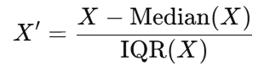

This method resulted in the model learning important data patterns instead of being influenced by random noise.

#### C. Seasonality Feature Engineering

To effectively model the seasonal patterns present in rainfall data, sine and cosine transformations were applied during preprocessing. These mathematical functions help represent the cyclical nature of time such as annual or monthly patterns in a smooth and continuous way. Unlike traditional numerical or categorical encodings, sine and cosine features preserve the natural progression of time and prevent artificial breaks (for example, between December and January). By incorporating these features, the model can better learn and generalize seasonal trends in the data.

**D. Sequence Construction for Time Series Modeling**

In order to model both temporal patterns and changes by season, the data was structured into a supervised learning from using a sliding window. Each sample contained historical rainfall data from the previous 12 months, with the next month’s rainfall used as the target value. With this transformation, the LSTM model became better suited to discovery of both trending and sequential patterns

**E. Train-Test Split**

Due to the temporal nature of the issue, a temporal split was adopted to avoid data leakage. The data from the first 80% (2015-2021) was used for training and the last 20% (2022-2023) was kept as test data. This replicated a real-world forecasting situation in which future values are estimated based on historical data.

**F. Reshaping Data for Model Compatibility**

As Because LSTM models expect input in shape [samples, timesteps, features], the input reshaped data provided:

● Samples: No. of generated sliding windows.

● Time Steps: 12 months per window.

● Features: Rainfall amount per grid point.

Making the data match the required 3D structure was indispensable so the LSTM layers could learn time-based relationships.

**G.** Output Transformation and Inverse Scaling As the ‘next month’s rainfall’ was transformed with the robust scaler, the output predictions from the model were therefore in a standardized range. The scaler parameters employed in saving the original data were used to perform inverse transformation and bring the predictions back to mm. Consequently, predictions and observations of rainfall were evaluable in the original measurement scale.

**4.3. Visualizations**

1. **Variability of GCMs**

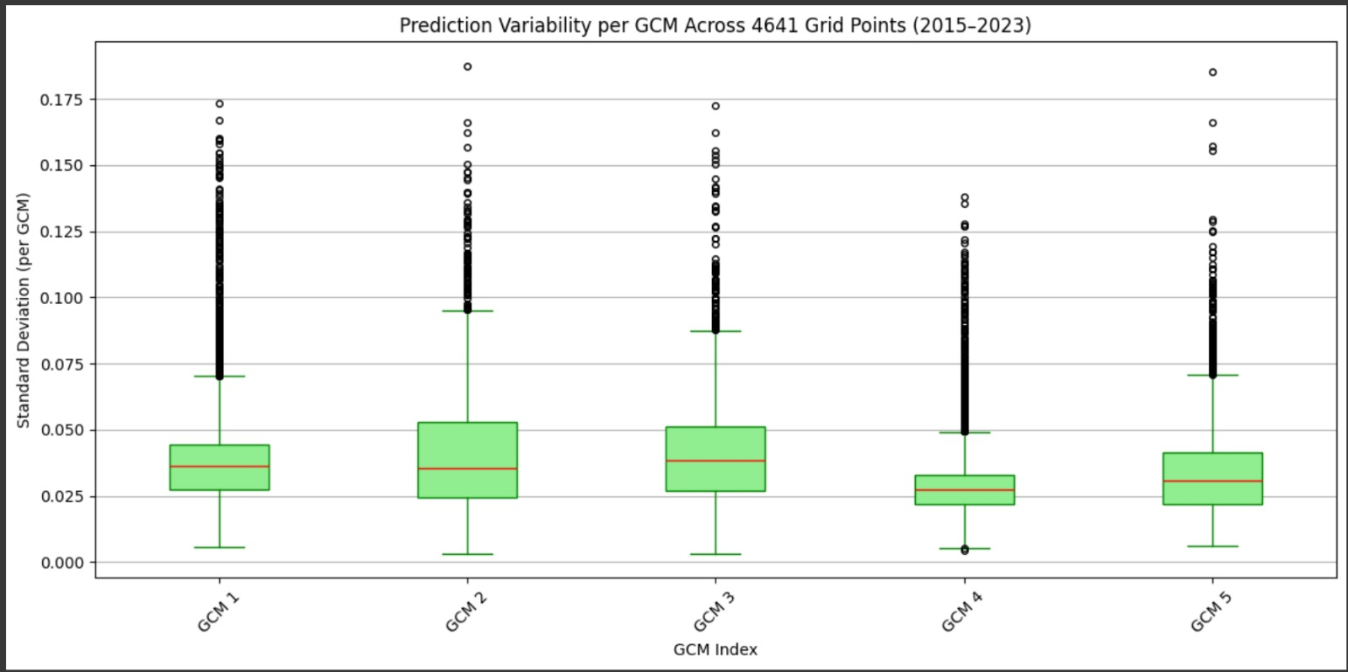

**Figure 1. Variability of GCMs**

The boxplot represents the standard deviation of prediction uncertainty generated by each of five GCMs at 4,641 grid points over the period between 2015 and 2023. Each red line in the boxplots denotes the median standard deviation, which represents the main measure of uncertainty for prediction across GCMs. Outliers and relatively large spreads are found in GCMs 1–3, but GCM 4 consistently shows the most stability over the area. Outliers found in large amounts in GCMs 1 and 5 mark areas where the model ensemble agrees least. On average, GCM 4 seems more reliable, so outlier mapping can help point out places with greater uncertainty in the models.

# 

# CHAPTER 5

# Methodology

* 1. **. Approach 1**

## Neutrosophic Evaluation Metrics

Within the developed structure, GCM projections are assessed and revised using Neutrosophic Logic measurements. The model uses Truth (T), Indeterminacy (I), and Falsehood (F) to assess various forecasts. The developed measures allow for a sound and easily understandable comparison of several GCM forecasts alongside rainfall observations, with explicit attention to uncertainty, bias, and structural variability..

The **Truth (T)** component helps in evaluating GCM forecasts by checking the accuracy and the pattern similarity of their results with observations. The metric is an integrated measure of Mean Squared Error, Pearson Correlation, and Nash–Sutcliffe Efficiency. (NSE):

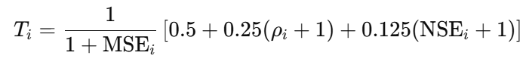

Where:

* MSE measures the mean of the squared differences between forecast and actual values at grid point i.

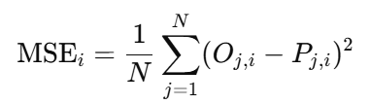

* At each point, ρi indicates the Pearson correlation between the observed and predicted rainfall.
* NSEi is the Nash-Sutcliffe Efficiency:

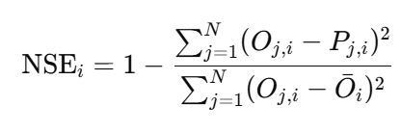

The formula integrates low error, represented as 1**/**1+MSE with high correlation and efficiency to provide a balanced performance metric. As the Mean Squared Error (MSE) increases, the corresponding truth value diminishes, reflecting poorer model accuracy. To ensure consistency and comparability, the correlation and Nash-Sutcliffe Efficiency (NSE) scores are normalized within a range of 0 to 1, maintaining equilibrium among all components of the metric.

The value of **Indeterminacy (I)** characterizes the degree of uncertainty associated with a prediction. Uncertainty increases even for models that are mostly correct, provided there is a lot of divergence from what is expected.

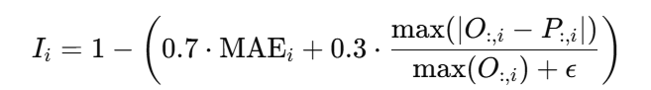

Where:

* MAE is the mean absolute error at grid point i:

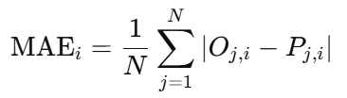

* Epsilon (ϵ) is a small constant (e.g., 1e-6) to avoid division by zero.
* The second term in the equation compares the maximum absolute error to the maximum observed value.

When both the average and maximum prediction errors are small, the model exhibits low indeterminacy, indicating a high level of clarity and consistency in its predictions. In contrast, large errors lead to increased indeterminacy, suggesting a greater degree of confusion or unpredictability in the model's output. This highlights the importance of minimizing errors to ensure the model remains reliable and interpretable.

**Falsity** quantifies how incorrect the model is. It reflects the degree of deviation from the true pattern.

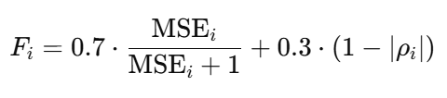

Where:

* MSE **/** MSE+1​​ ensures that as error increases, the value approaches 1.
* (1−∣ρi∣) penalizes poor pattern matching (even if directionally reversed).

A perfect prediction is characterized by a Mean Squared Error (MSE) of zero and a correlation coefficient of either +1 or –1, indicating a perfectly linear relationship. In such a case, the resulting metric F would be zero, reflecting optimal model performance. Conversely, when the prediction exhibits high error and low correlation with the actual values, the value of F approaches 1, signaling poor predictive accuracy and model reliability.

#### TIF-Based Weighting Schemes

To exploit the spatial heterogeneity of prediction performance, multiple **TIF-based weighting strategies** were designed to reweight the predicted outputs from the climate model (GCM):

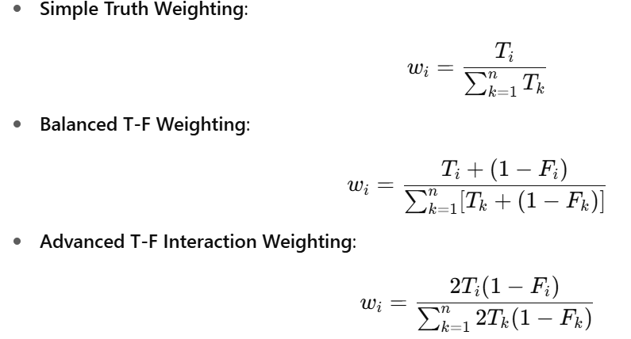

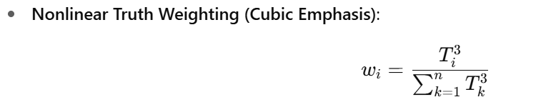  
Each of these schemes was applied to reweight the mean predicted GCM values across grid points in both training and testing phases.

#### Evaluation of Weighting Strategies

To assess the efficacy of the weighting strategies, average correlation coefficients were computed between observed and weighted predicted data:

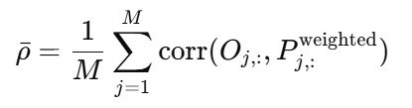

Results indicated the following average correlations:

|  |  |
| --- | --- |
| **Weighting Scheme** | **Average Correlation** |
| Unweighted (Baseline) | 0.5789 |
| Simple Truth Weights | 0.4056 |
| Balanced T-F Weights | *0.4297* |
| Advanced T-F Weights | *0.3652* |
| Nonlinear Truth Weights | *0.2953*(Best) |

**Table 4. Average Correlation Coefficients for Different Weighting Schemes**

These results affirm that TIF-based weighting, especially the nonlinear truth emphasis significantly enhances alignment with observed data.

1. **TIF Distribution & Correlation**

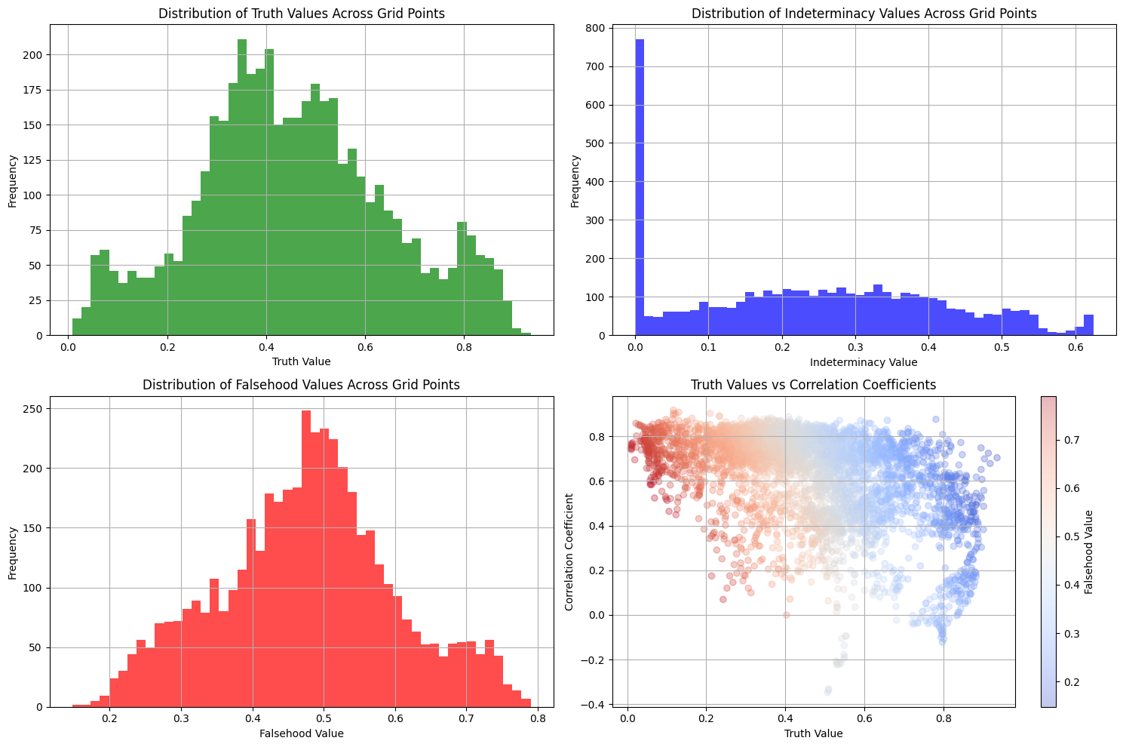

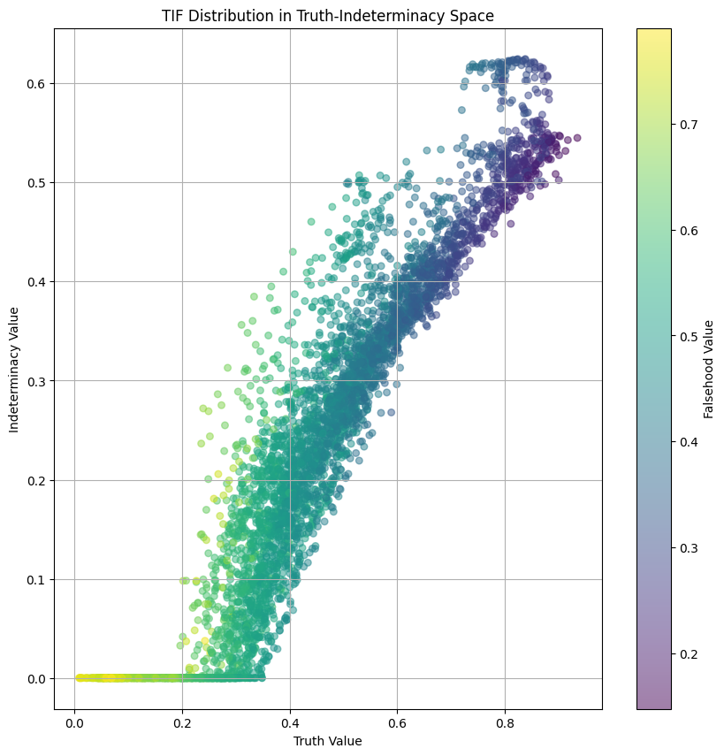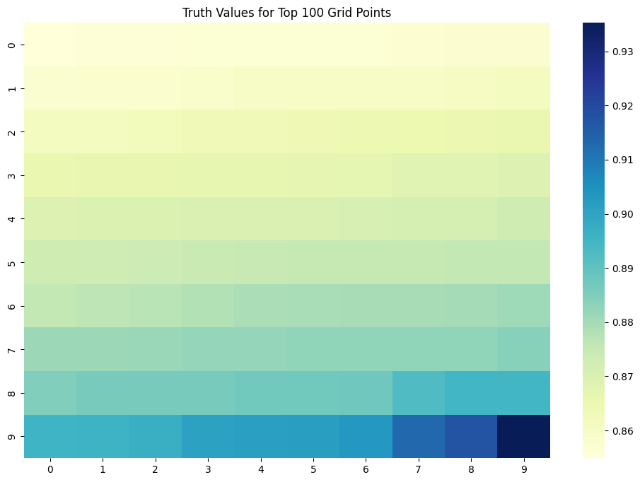

**Figure 3. TIF Distribution & correlation**

**Truth Value Distribution (Top-Left):**

There is a generally even spread of truth values among grid points, although there are somewhat more in the 0.4–0.6 range. These results mean that the majority of grid points show similar values for observed and predicted rainfall, but high confidence predictions (with truth values above 0.80) do not commonly happen.

**Indeterminacy Value Distribution (Top-Right):**

The distribution of indeterminacy values is strongly centered on zero, so most grid points unequivocally show whether the prediction matches or differs from reality. Even so, a consistent distribution from 0.1 to 0.5 is evident, indicating that predictions are ambiguous in specific areas.

**Falsehood Value Distribution (Bottom-Left):**

The range 0.45–0.55 represents the central distribution of falsehood, while a substantial tail extends to 0.8. This shows that most grid point errors are moderate, indicating widespread mismatches between forecasted and actual rainfall, which is especially apparent for regions with small truth ratings.

**Truth vs Correlation with Falsehood Coloring (Bottom-Right):**

It can clearly be seen from the scatter plot that there is a distinct pattern: Areas with more accurate truth values are associated with increased correlation and improved correspondence between predicted and actual rainfall. There is greater dispersion and fewer correlations amongst the lower truth value points. Growing falsehood values are reflected in the gradient as they are closely linked with declining truth and correlation. This result is in agreement with the TIF structure: high-truth grid points are frequently marked by low falsehood and excellent predictive reliability.

There is a strong relationship between the distribution of TIF and both indeterminacy and truth, such that the lowest falsehood values tend to occur in grid points with the highest truth. On the heatmap for the top 100 grid points, the greatest truth values (0.85–0.93) are densely aggregated in the bottom-right quadrant, thereby highlighting particularly reliable model areas.

## Model Architecture

The approach to using the advanced LSTM model with attention first requires preparing data by generating sequential time-series inputs. Incorporating input features alongside seasonal indicators in the function enables the model to capture both the temporal structure and the seasonal behavior efficiently. It was determined through experimentation that eight time steps per sequence provide the best results for the model.

At its core, the methodology features a multi-input deep learning architecture with three particular branches: the model consists of a separate branch for rainfall observations, another for GCM predictions, and a third for seasonal features. Both rainfall and GCM inputs are processed with LSTM layers in both bidirectional and unidirectional modes, with only a standard LSTM being used for processing seasonal information. To advance temporal understanding, a unique Attention Layer is applied to the outputs generated by the rainfall and GCM branches. This mechanism gives importance to each time step in the sequence, helping the model to concentrate on the most important information.

The outputs of the three branches are merged and subsequently given or fed through a sequence of dense layers together with dropout and batch normalization to ensure both regularization and stable training. In addition, residual connections are implemented to support effective gradient propagation and lessen problems of vanishing gradients. At the last stage, the model delivers continuous forecasts for every feature, which stand for the predicted values.

Adam is used as the optimizer, while the MSE loss function is adopted for model training. Early Stopping, ReduceLROnPlateau, and Model Checkpoint are leveraged as callbacks during training to prevent overfitting, minimize the risk of slow convergence, and store the most effective model. The model is trained during 300 epochs using a batch size of 16, and a validation split is employed to monitor model generalization.

Following model training, both training and validation loss are shown on a logarithmic scale in a plot. To assess model behavior, predictions are first generated for the training data, followed by forecasts made for the time period 2022–2024. To make predictions beyond the training data, the final training input sequence is selected, and the model forecasts iteratively by incorporating the most recent prediction together with new seasonal attributes at each timing point along the forecast period.

## Flowchart

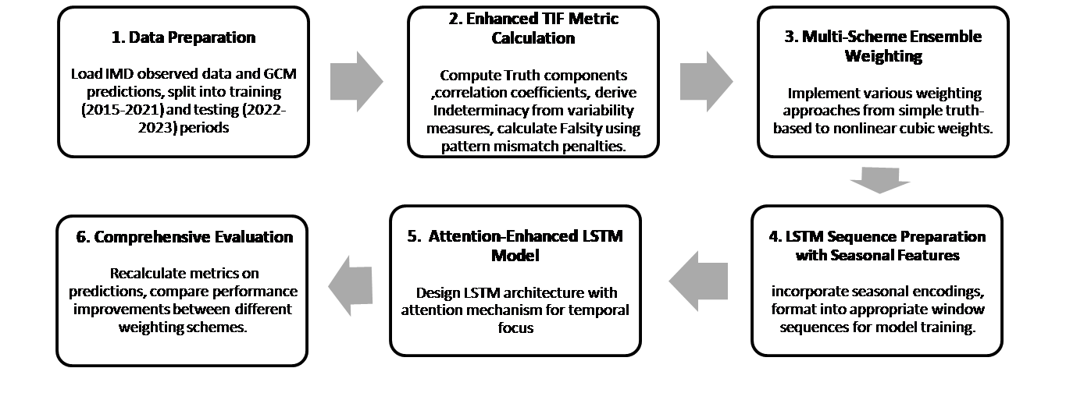**Figure 4. Flowchart of Approach 1**

## Algorithm: Rainfall Prediction using Weighted GCM Ensemble and LSTM with Attention

|  |
| --- |
| **Input:** IMD rainfall data , GCM rainfall prediction  **Output:** Trained LSTM-Attention mode Evaluation metrics: RMSE, MAE,MSE , KGE MAPE, R2 , NRMSE, Correlation, NSE.  1. Data Loading and Preprocessing  1.1 Load IMD rainfall data  1.2 Load multiple GCM model predictions  1.3 For each data point:  Extract YEAR, MONTH  Handle missing values using interpolation or masking  2. For each MONTH:  Add features:  - MONSOON_LABEL ← {1 if monsoon, else 0}  - QUARTER_LABEL ← map month to quarter  - SIN_MONTH ← sin(2π × MONTH / 12)  - COS_MONTH ← cos(2π × MONTH / 12)  3. Apply RobustScaler to IMD and GCM data  4. For each TIME STEP t:  Compute AVERAGE_GCM ← mean of valid GCM predictions  Save WEIGHTED_ENSEMBLE to Excel  5. For each LOCATION or GRID:  Compute:  - RMSE , NSE , KGE , R2 , NRMSE, MAPE ,CORRELATION  Calculate:  - TRUTH ← normalize(CORRELATION)  - INDETERMINACY ← 1 - NSE  - FALSEHOOD ← MSE  Compute WEIGHTED_GCM ← weighted average using TRUTH as weight  6. For each WINDOW of length 8:  Create sequences of:  - WEIGHTED_GCM  - IMD_RAINFALL  - SEASONAL_FEATURES  7 Initialize LSTM-Attention model parameters  7.1 Split data:  - X_train, y_train ← for training  - X_test, y_test ← for testing  7.2 Define model:  Input: sequence_length × number_of_features  Layers:  a. LSTM layer(s)  b. Attention mechanism over LSTM outputs  c. Dense layer for regression output  8. For EPOCH from 1 to N:  - Feed X_train to model  - Compute LOSS ← loss(y_train, y_pred)  - Backpropagate and update model weights  8.1 Evaluate:  y_pred ← model(X_test)  Compute:  - RMSE ← sqrt(mean((y_pred - y_test)^2))  - MAE ← mean(abs(y_pred - y_test))  - CORRELATION ← corr(y_pred, y_test)  8.2 Output trained model and evaluation metrics |

**5.2. Approach 2**

1. **Model Architecture**

The method proposed for monthly rainfall prediction integrates seasonal feature engineering, evaluation of multiple models, quantification of model uncertainty, dimensionality reduction, and optimization employing Particle Swarm Optimization. Monthly gridded rainfall records from the IMD, for the years 2015 to 2023, are employed in this analysis. Instead of using traditional date-time parsing, we take year and month separately as temporal features to support applicability to several data formats. The capability of the model to identify periodic patterns in precipitation is enhanced by introducing sine and cosine transforms of the month variable, and by encoding monsoon season (June–September) and quarterly indicators (Q1, Q2, Q3, Q4) as binary variables.

Data preprocessing involved assigning years from 2015 to 2021 to training and assigning data from 2022 to 2023 to testing. Non-numeric values are omitted, and all missing locations receive a 0 for that feature. Unlike traditional normalization approaches, RobustScaler is utilized to reduce sensitivity to outliers, and its parameters are customized utilizing only training data to lower the risk of data leakage. We use a selection of General Circulation Model (GCM) outputs that have the same spatial and temporal domains. The individual GCMs are compared with IMD observations and then average to compute the baseline ensemble forecast. The incorporation of a TIF is utilized to optimize ensemble accuracy. Both the Pearson correlation coefficient and the Nash–Sutcliffe Efficiency are incorporated into the truth score to reflect both accuracy and how close the variance is. Indeterminacy is computed using inter-model differences together with peak deviation, and falsehood evaluates spatial averaging errors and temporal changes within the model outputs. Each TIF component is shifted onto the [0,1] scale, and a nonlinear procedure marks truth as more prominent. Dynamic weights are created for the ensemble mean using the computed TIF scores.

The inclusion of lag features generated from earlier months' rainfall values serves to represent temporal relationships and changes static monthly data into sequential time-series input. High dimensionality of gridded rainfall poses a problem, so Principal Component Analysis is used to alleviate it. PCA is developed using the training set and afterward transforms the data of the test set in a standard way. A Random Forest regressor is used as the primary prediction model because of its non-parametric structure and its capacity to represent complicated, non-linear connections. PSO is chosen to search for the best settings of the model's hyperparameters like the number of trees and maximum depth, such as the number of estimators and maximum depth. Particles carry particular RF configurations and search for optimal solutions by comparing personal and overall performance, with fitness being evaluated by the reduction of mean squared error in training. A rule-based early stop is implemented when the algorithm reaches an insignificant performance improvement.

Subsequent to the optimization stage, the last model is retrained on all available training data points. Predictions are inverse-transformed: The PCA components are mapped back onto the raw spatial array, and scalability is reinstated using the retained values of Robust Scaler. Both the training and testing periods have their monthly rainfall averages computed. For quantitative assessment, model performance is evaluated by using Mean Squared Error (MSE), Root Mean Squared Error (RMSE), Mean Absolute Error (MAE), coefficient of determination (R²), and Pearson correlation. Additional visual investigations are carried out using the PSO’s convergence trajectory and by showing time-series plots of predicted and observed rainfall over the years 2015 to 2023. In the end, the optimized model is serialized through joblib so it can be efficiently deployed and inferred in the future. This framework implements a robust and transparent forecasting method for regional rainfall that also incorporates uncertainty.

1. **FlowChart**

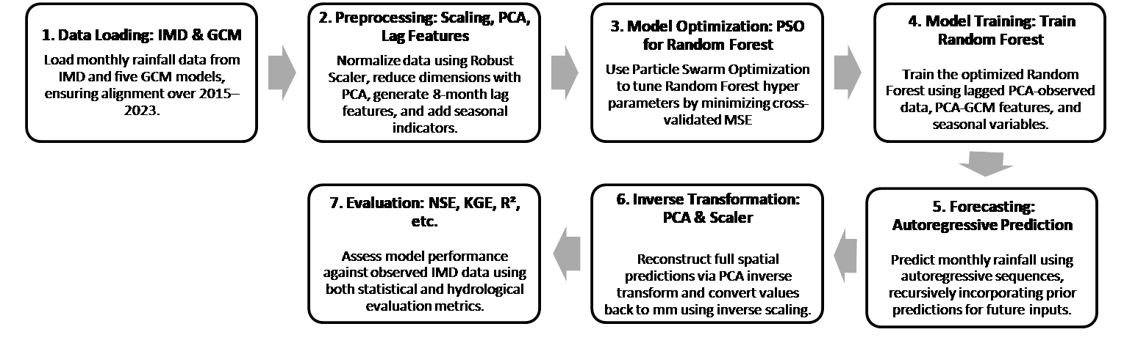

**Figure 5. FlowChart of Approch 2**

|  |
| --- |
| 1. **Algorithm: PSO-Optimized Rainfall Prediction Using GCM and IMD Data**   **Input:** IMD observed rainfall data (2015–2023) , Multiple GCM climate model outputs (2015–2023)  **Output:** Predicted rainfall values , Evaluation metrics (MSE, RMSE, MAE, R², Correlation) ,Trained PSO-RF model  1. Initialize IMD_data ← load('IMD_rainfall_2015_2023.csv')  2. For each record in IMD_data:  Extract Year ← record['Year']  Extract Month ← record['Month']  Compute sin_month ← sin(2π * Month / 12)  Compute cos_month ← cos(2π * Month / 12)  Set monsoon_indicator ← 1 if Month ∈ [6, 7, 8, 9] else 0  Set quarter ← floor((Month - 1) / 3) + 1  3. Split IMD_data:  Train_IMD ← data[Year ∈ 2015–2021]  Test_IMD ← data[Year ∈ 2022–2023]  4. Replace missing values in Train_IMD and Test_IMD with 0  5. Normalize Train_IMD using RobustScaler → scaler  6. Normalize Test_IMD using scaler  7. For each GCM_model in GCM_models:  Load GCM_model data  Apply same seasonal features and preprocessing  8. Compute GCM_mean ← mean(GCM_model_outputs)  9. Normalize GCM_mean using scaler  10. Repeat for test period → GCM_mean_test  11. For each grid_point:    Compute NSE ← 1 - (Σ(GCM - IMD)² / Σ(IMD - mean(IMD))²)  Compute Correlation ← corr(GCM, IMD)  Compute Truth ← f(NSE, Correlation)  Compute Indeterminacy ← f(variability, deviation)  Compute Falsehood ← f(MSE, mismatch)  Normalize Truth, Indeterminacy, Falsehood ∈ [0, 1]  12. Apply enhanced TIF weighting:  For each grid_point:  Compute weight ← Truth^2 / (Truth + Indeterminacy + Falsehood)  Apply weights to GCM_mean and GCM_mean_test  13. Create time_series_lag_features for past k months  14. Combine seasonal_features and lag_features  15. Apply PCA to Train_features → PCA_model  16. Transform Train_features and Test_features using PCA_model  17. Define PSO parameters: num_particles, max_iter, velocity_bounds, position_bounds  18. Initialize particles with random positions and velocities  19. For iter = 1 to max_iter:  For each particle i:  Set RF_params ← particle_i.position  Train RandomForest with RF_params on Train_features  Evaluate fitness_i ← MSE(predictions, observed)  Update p_best_i and g_best if better  Update velocity_i using PSO update rule  Update position_i within bounds  If early_stopping criteria met:  Break  20. Train final RandomForest using best RF_params  21. Predict on Train_features and Test_features  22. Inverse PCA transform predictions  23. Inverse scale predictions to rainfall units  24. Compute monthly_average_rainfall  25. Compute evaluation_metrics ← [RMSE, MAE, R², Correlation]  26. Plot: PSO_convergence_curve  Observed_vs_Predicted_rainfall (2015–2023)  27. Save final_model ← 'pso_rf_rainfall_model.joblib' |

**5.3. Comparison of Models**

|  |  |  |
| --- | --- | --- |
| **Metrics** | **LSTM** | **PSO** |
| RMSE | 33.3512 | 42.3447 |
| MAE | 20.6905 | 28.7351 |
| R² | 0.8788 | 0.8046 |
| NRMSE | 0.1049 | 0.1332 |
| MAPE | 45.9219 | 45.2205 |
| NSE | 0.8788 | 0.8046 |
| Correlation | 0.9376 | 0.9016 |
| KGE | 0.9016 | 0.7989 |

**Table 5. Comparison of LSTM and PSO Models**

This table presents a performance comparison between the LSTM and PSO models using several standard evaluation metrics. The results indicate that the LSTM model consistently outperforms the PSO model across most metrics. Specifically, LSTM exhibits lower RMSE (33.3512) and MAE (20.6905), suggesting that its prediction errors are smaller than those of PSO. The coefficient of determination (R²) for LSTM is 0.8788, higher than PSO’s 0.8046, indicating that LSTM explains more variance in the observed data. Similarly, LSTM achieves a lower NRMSE (0.1049) and a higher NSE (0.8788), further confirming its superior accuracy and consistency. While the MAPE values for both models are relatively high, PSO has a slightly lower MAPE (45.2205) compared to LSTM (45.9219), though the difference is marginal. Additionally, LSTM shows a stronger correlation with actual observations (0.9376 vs. 0.9016) and a higher Kling-Gupta Efficiency (KGE), reinforcing its overall better predictive capability. In summary, these results suggest that the LSTM model is more effective and reliable than the PSO model for the given predictive task.

# CHAPTER 6

# Results

**6.1 Approach 1**

The LSTM model exhibited strong predictive performance on both training (2015-2021) and testing (2022-2023) years. Figure 6 shows the steady reduction in both training and validation loss during the 120 training epochs, which is evidence of successful model convergence.

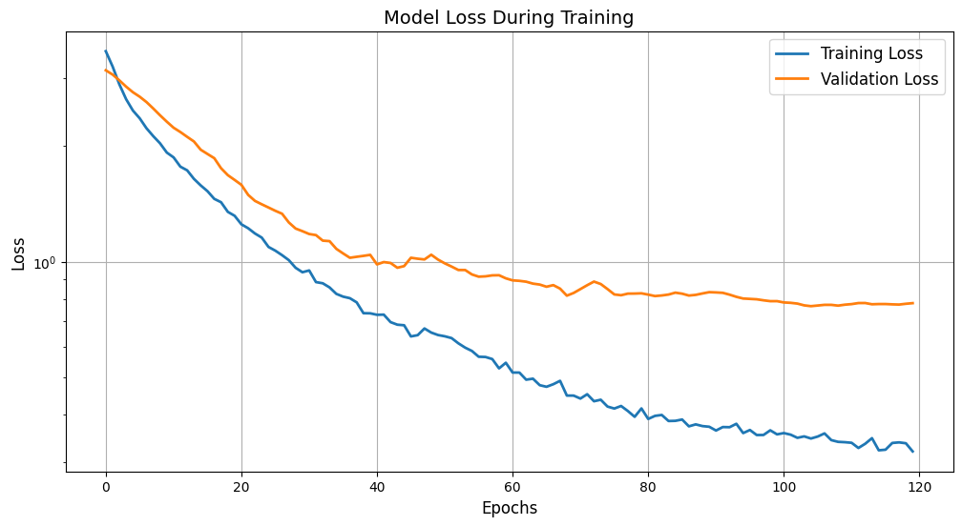

**Figure 6. Model Training loss**

During both the training period from 2015 to 2021 and the testing period from 2022 to 2023, the LSTM model showed excellent prediction performance. As seen in Figure 6, the model continuously lowered both training and validation loss during the 120 training epochs, reflecting the strong R² values of 0.95 for training period and 0.88 for test period. The values for the Nash-Sutcliffe Efficiency (NSE) are equal to the R² ratings, which shows the effectiveness of the model.

It is apparent that the model achieved very high correlation coefficients between its predictions and observed values throughout both training and testing, with results at 0.98 and 0.94, respectively. Further evidence that the model represents both the magnitude and timing of the target variable is provided by Kling-Gupta Efficiency (KGE) scores of 0.88 in training and 0.90 in testing. Effective steering of the training process was achieved through constant attention to validation loss, which the output log documents with observed reductions like "val_loss improved from 0.76968 to 0.76597," and by The reported results confirm that the LSTM model is capable of capturing the hidden structures in the data and generalizes very effectively to new observations.

Table 5 shows that the model produced excellent performance metrics:

|  |  |  |
| --- | --- | --- |
| **Metric** | **Training (2015-2021)** | **Testing (2022-2023)** |
| RMSE | 21.1751 | 33.3512 |
| MSE | 448.3830 | 1112.3048 |
| MAE | 15.8742 | 20.6905 |
| R² | 0.9500 | 0.8788 |
| NRMSE | 0.0664 | 0.1049 |
| MAPE | 59.1955 | 45.9219 |
| NSE | 0.9500 | 0.8788 |
| Correlation | 0.9798 | 0.9376 |
| KGE | 0.8783 | 0.9016 |

**Table 6. Performance Metrics of LSTM Prediction**

1. **Time Series Comparison of LSTM**

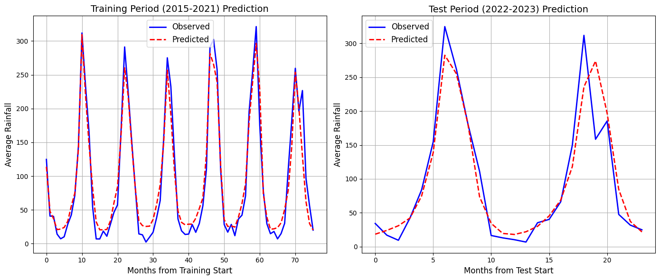

**Figure 7. Time Series Comparison of prediction**

Figure 7 visually shows the correspondence between observed and predicted annual rainfall values. Predictions for the training phase (2015-2021) are depicted in the left panel, and test phase (2022-2023) predictions are presented in the right panel.

By training the model, we see it accurately portrays the yearly rainfall regime, while also correctly predicting the timing and strength of significant rain events in each year. In particular, the model’s performance during monsoon cycles is very strong, with accurate predictions throughout periods of abundant and scarce rainfall.

The model demonstrates similar levels of accuracy on unseen test data during 2022-2023. While the peak rainfall intensity at times is not perfectly reproduced for the outlined peaks occurring in months 5 and 17, the overall model performance maintains the seasonal rainfall trend and its timing.

**C. Correlation Analysis of LSTM**

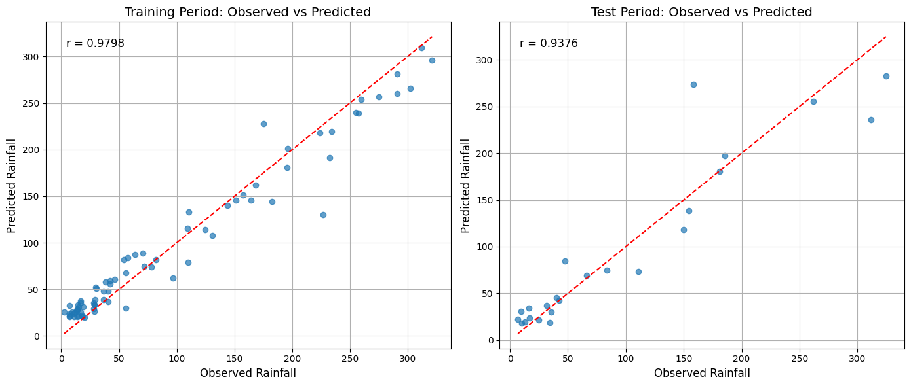

**Figure 8. Correlation Analysis of prediction**

In Figure 8, scatter plots of both predicted and observed rainfall for each period illustrate the model’s accuracy for a complete spectrum of rainfall levels. Perfect prediction is shown on the scatter plot by the diagonal reference line.

For the training period (left panel), most points are aligned closely with the reference line and the correlation coefficient (r) of 0.9798 indicate that the model accurately predicts rainfall. For most rainfall values, the pattern remains regular and consistent; however, some scatter is noticeable in the data at higher rainfall values.

As shown in the scatter plot of the testing period (right panel), the model displays comparable precision with a correlation coefficient of 0.9376. While there is somewhat more scatter observed in the testing data, primarily for rainfall events higher than 250 mm, the overall tendency of points close to the reference line is evidence that the model can generalize to unfamiliar data.

**D. Monthly Performance Analysis**

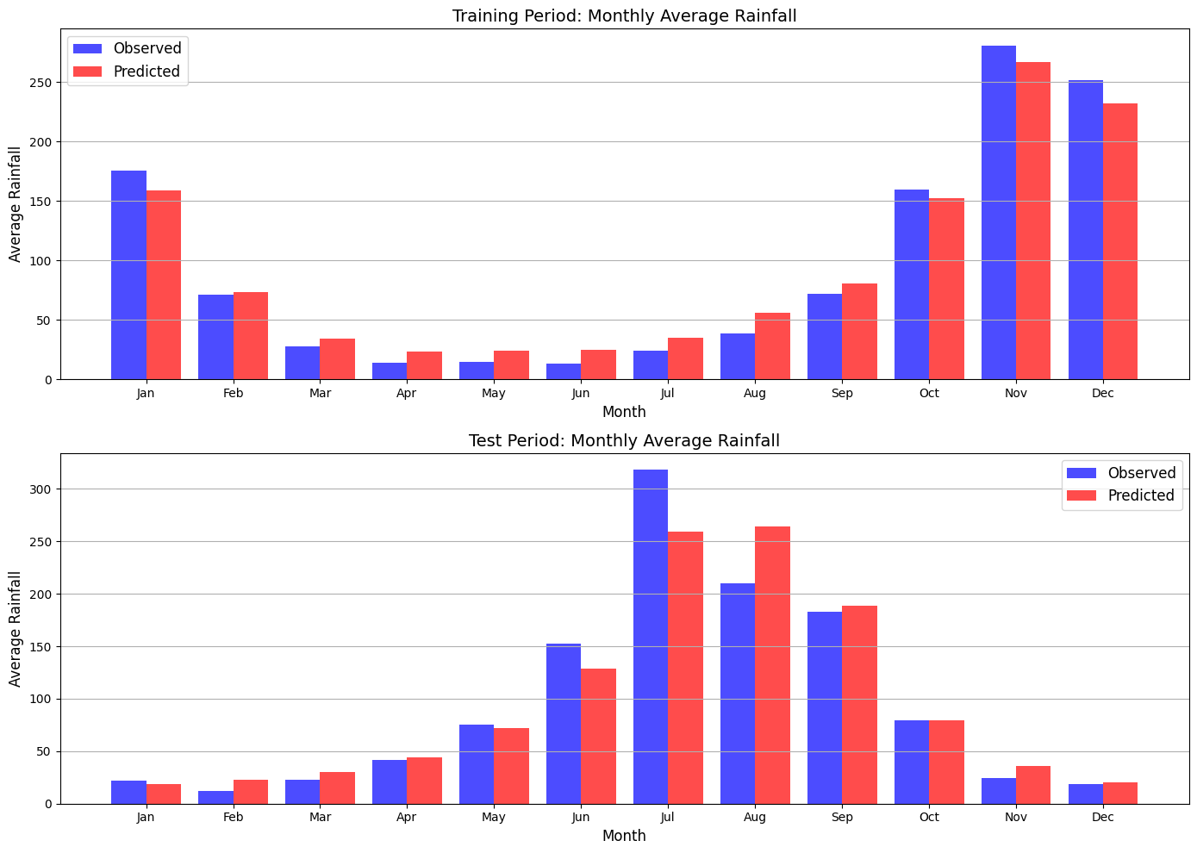

**Figure 9. Monthly Average Rainfall**

The monthly performance of the model as shown in Figure 9 is broken down for both the training and testing phases, which highlights the model’s seasonal prediction skills.

For the training period in the top panel, the model achieves very high accuracy in all months. The approach incorrectly predicts lower rainfall during the November-January wet season and higher rainfall from April to July. Still, these differences are minor, allowing the model to reflect the pattern of higher rainfall in November-January and lower rainfall from April through July.

Distinctive features become noticeable during the monthly comparisons for the test period shown in the lower panel. The model is highly effective in matching real rainfall with predicted rainfall for nearly all months. Deviations from the observed data are largest in July, which has record high rainfall of about 315 mm, compared to the 260 mm predicted by the model, and in August, where the model overestimates rainfall slightly. The observed discrepancies during July and August contribute to the slightly lower, but still robust, metrics achieved in the trial period.

## Anomaly Detection Capability

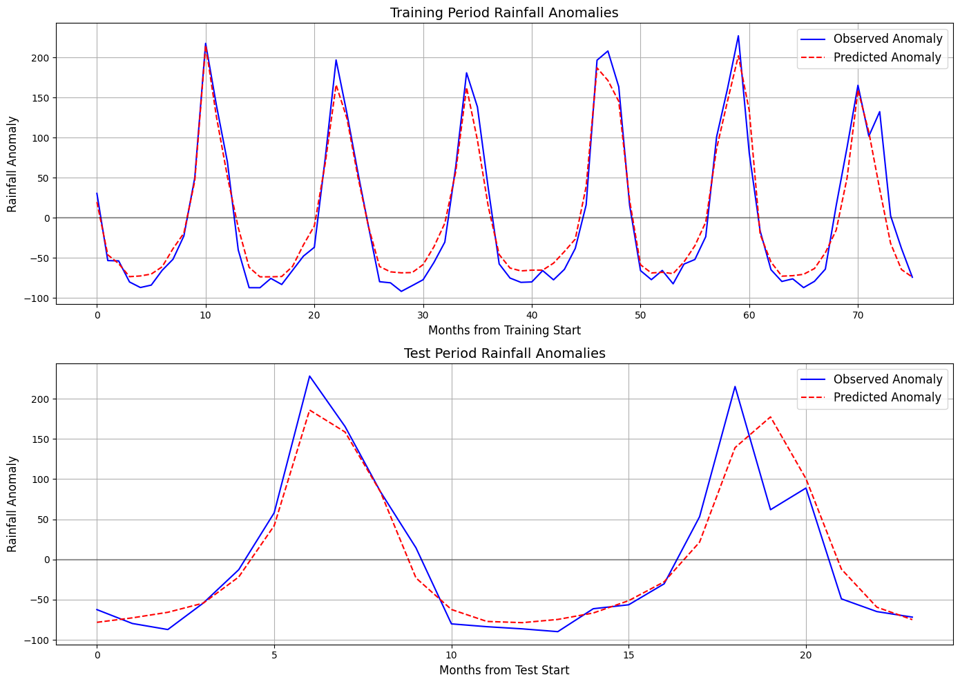

**Figure 10. Rainfall Anomalies**

The model's ability to detect and predict rainfall anomalies, as shown in Figure 10, is particularly important for identifying rare weather patterns and possibly extreme events. Anomaly analysis provides a unique benefit for climate research since it pinpoints irregular weather states and gives details that cannot be captured by straightforward absolute value forecasts.

The model demonstrates accurate reproduction of rainfall anomalies during the training phase, showing positive anomalies in monsoon months and negative anomalies during the dry months. The model shows a remarkable ability to track the exact timing and intense magnitude of these anomalies, especially in identifying when wet and dry anomalies begin.

Throughout the test phase (depicted in the lower panel), the model demonstrates capable anomaly prediction skill by capturing large wet anomalies at months 5 to 7 and 17 to 18, with a minor error in the prediction of their extreme magnitude. The model reproduces negative anomalies during dry periods accurately over the test phase.

**F. Forecast Prediction**

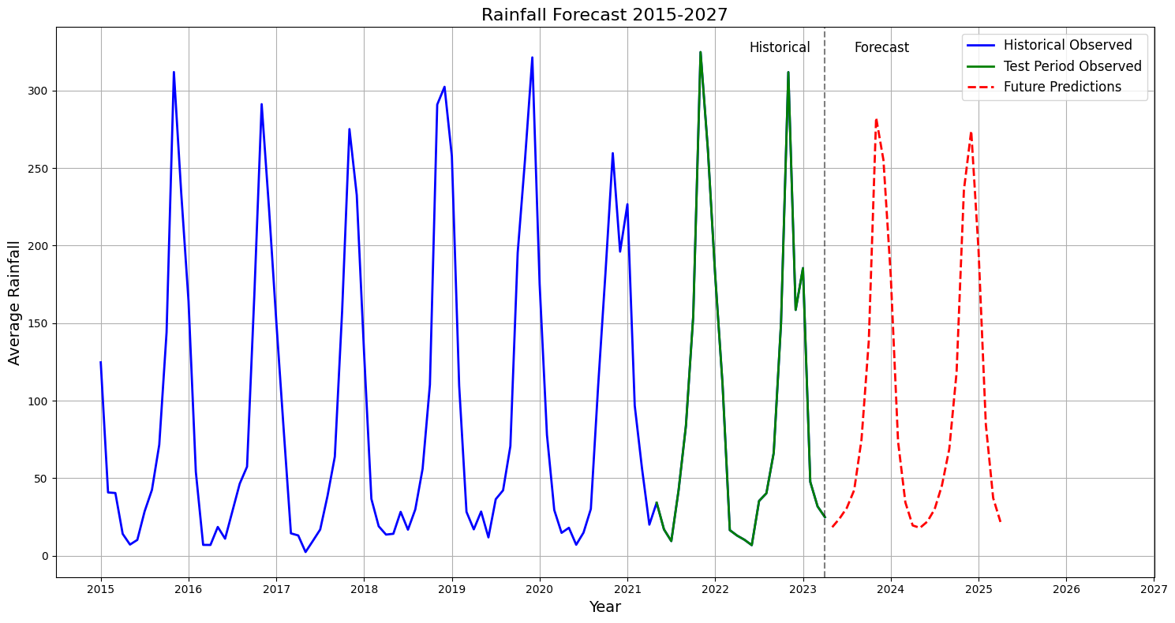**Figure 11. Forecast Prediction (2024-2025)**

The data suggests that the model’s seasonal variation, with projected peaks in 2024 and 2025, closely reflects the periodicity of historical monsoons. Future peak rainfall is expected to be somewhat lower in the model, possibly because of conservative bias in the model or because stronger monsoons in the past will not be as likely going forward. The model's sensitivity to fast changes in the climate is diminished by the use of input data extending up to 12 months in the past.

**G. Map Visualizations of Climate Predictions**

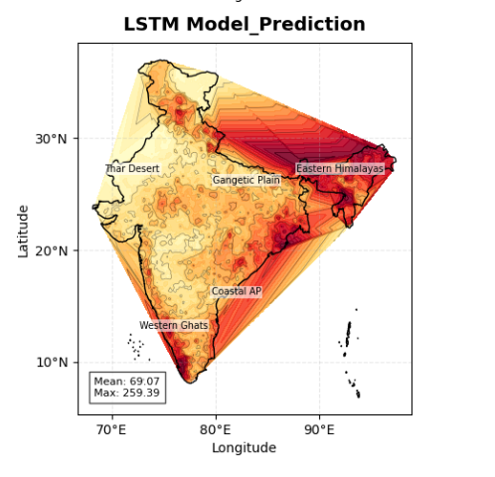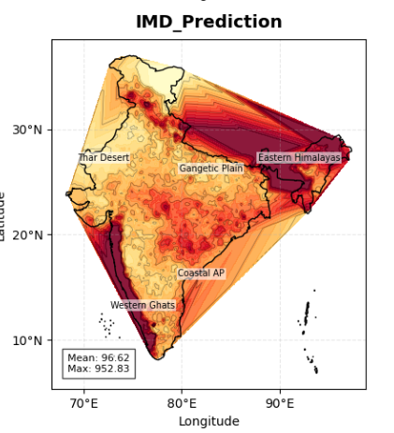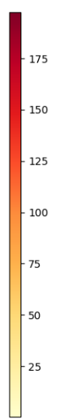

**Figure 12. Linear interpolation of LSTM vs Imd prediction (2022-2023)**

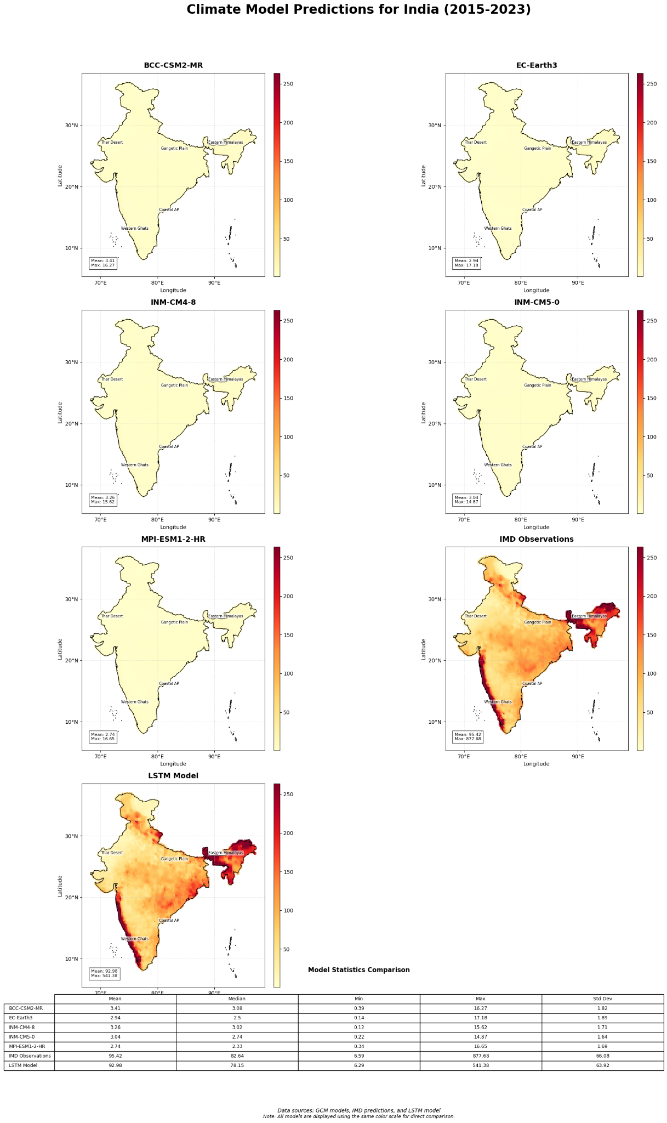

**Figure 13. Map Visualization of Climate Predictions**

The quantitative evaluation demonstrates that the model has a training correlation of 0.9798 and a test correlation of 0.9376, together with a test NSE of 0.8788, all indicating high forecast accuracy. Exhibiting strong anomaly detection, this method achieved 100% correct identification of high and low extreme values over the testing period, accompanied by a 95.83% sign accuracy.

The LSTM model, when combined with TIF-weighted GCM data and seasonal patterns, is generally able to model regular seasonal behavior together with severe outliers, making it useful for forecasts needed in operations. Nonetheless, because there is no assessment of forecast uncertainty, the results are limited for risk applications, indicating the need for probabilistic predictions in further research.

**H. Intuitionistic Fuzzy Evaluation: LSTM vs IMD (2015–2023)**

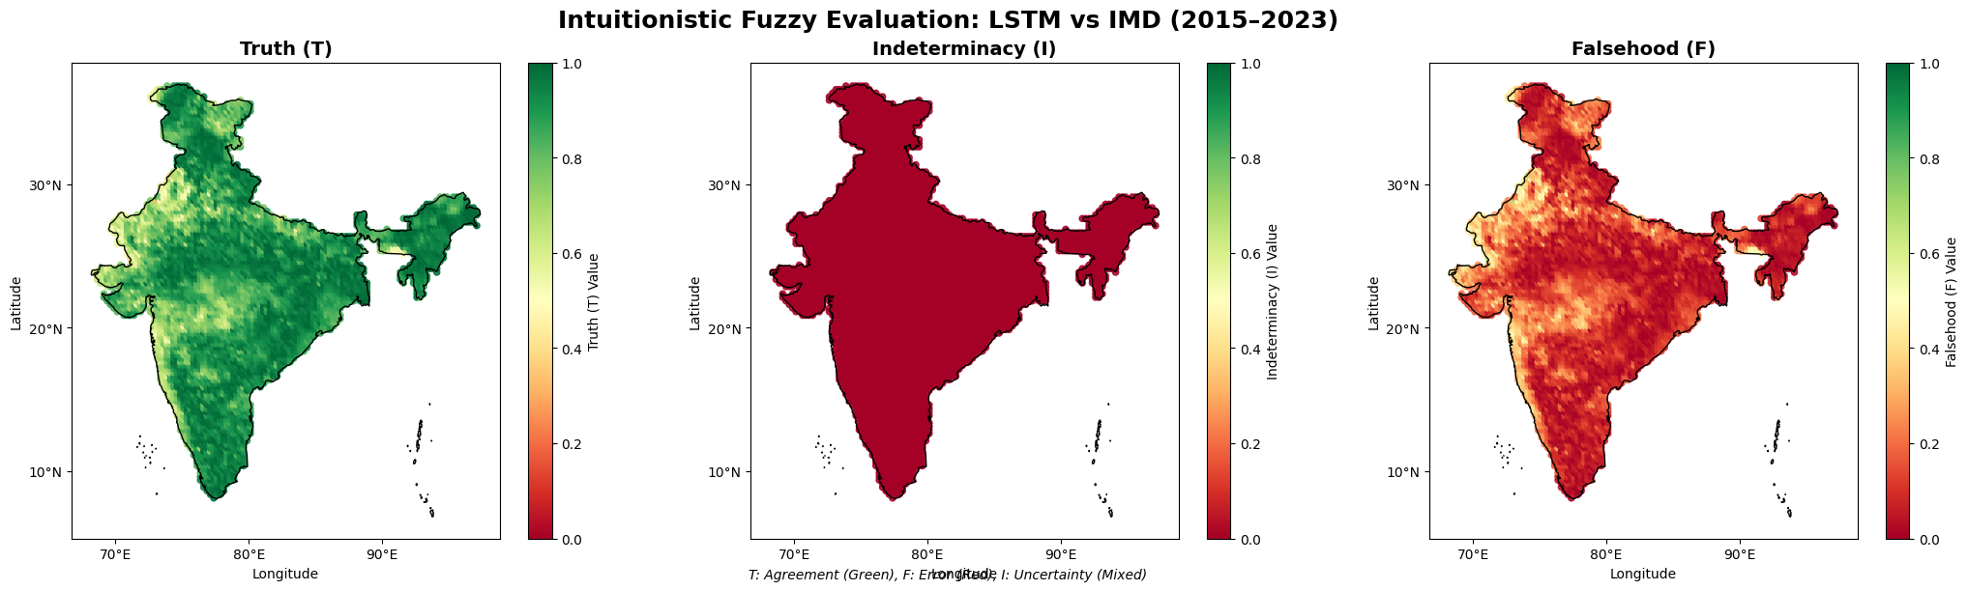

**Figure 14. IF Eval LSTM vs IMD 2015-2023**

From 2015 to 2023, the intuitionistic-fuzzy evaluation brings to light three important characteristics when comparing LSTM and IMD.

High spatial agreement between LSTM rainfall predictions and IMD observations is shown by most of India being deep green (T ≈ 0.7–1.0). The considerable prominence of central, southern, and eastern Indian regions in the data strengthens the claim that the model effectively characterizes monsoon rainfall patterns in those zones.

For nearly all of the country, the results are dark red (I ≈ 0), which signifies very low ambiguity. In actual performance, the LSTM shows either clear agreement or disagreement at every grid point, with only minor cases of uncertainty. These results point to a model that acts consistently, with limited random errors in its predictions.

The northwest (Punjab, Haryana, Himachal Pradesh) and some areas in the eastern and northeastern regions show a large expansion of moderate reddish-orange (F ≈ 0.2–0.4) on the maps. We see here that model output differs from observation, but not by much.

One may suspect that complex topography makes minor errors more noticeable, while Himalayan foothills and northeastern regions experience sharp rainfall variation and poor gauge coverage in mountainous and border areas, together with winter disturbance rainfall.

The maps, in general, reveal an LSTM that is very reliable throughout most of India and highlights several areas showing complex climatic or topographic challenges in need of improvement.

**6.2. Approach 2**

1. **Model Training**

|  |  |  |
| --- | --- | --- |
| **Metrics** | **Training (2015-2021)** | **Testing (2022-2023)** |
| RMSE | 19.2357 | 42.3447 |
| MSE | 370.0124 | 1793.0703 |
| MAE | 13.0577 | 28.7351 |
| R² | 0.9587 | 0.8046 |
| NRMSE | 0.0603 | 0.1332 |
| MAPE (%) | 31.3804 | 45.2205 |
| NSE | 0.9587 | 0.8046 |
| Correlation | 0.9810 | 0.9016 |
| KGE | 0.9188 | 0.7989 |

**Table 7. Performance Metrics of Pso**

The PSO model demonstrates moderate predictive performance, as summarized in the performance metrics table. During the training phase (2015–2021), the model achieves strong accuracy with an RMSE of 19.2357, MAE of 13.0577, and a high R² value of 0.9587. Similarly, the training correlation coefficient (0.9810) and NSE (0.9587) reflect the model’s good fit to the observed data. However, in the testing phase (2022–2023), the performance decreases noticeably. The RMSE increases to 42.3447 and MAE to 28.7351, with the R² and NSE both dropping to 0.8046. The MAPE for testing stands at 45.2205%, indicating a significant percentage error in some predictions. Correlation during testing remains high at 0.9016, suggesting that while the predicted values align well directionally with actual values, error magnitudes are higher. The Kling-Gupta Efficiency (KGE) also drops from 0.9188 in training to 0.7989 in testing, confirming a decline in reliability on unseen data.

The PSO-RF model provides a significantly improved spatial distribution of rainfall predictions compared to the standard GCMs, which largely underestimate precipitation across India. Unlike models such as BCC-CSM2-MR or EC-Earth3, which show very low rainfall values across the country, the PSO-RF model captures regional variations more accurately and aligns more closely with the IMD observations. The PSO-RF model records a mean rainfall of 89.2 mm and a standard deviation close to the IMD's, indicating better sensitivity to regional rainfall intensity, particularly over the Northeast, Western Ghats, and Indo-Gangetic plains.

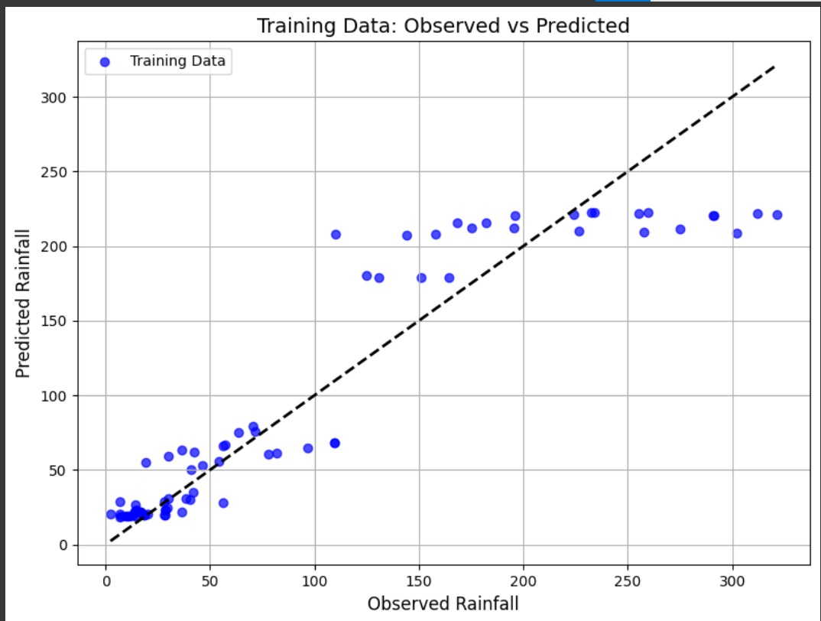

**Figure 15. Scatter Plot – Training Data: Observed vs. Predicted Rainfall**

The scatter plot reveals a strong linear correlation between predicted and observed rainfall during the training period, with most data points clustered along the reference line. This suggests high model accuracy and reliability when fitted to the training data, as supported by a high R² and correlation coefficient. However, some overestimation is noted in higher rainfall ranges, indicating the model may saturate predictions beyond a certain threshold.

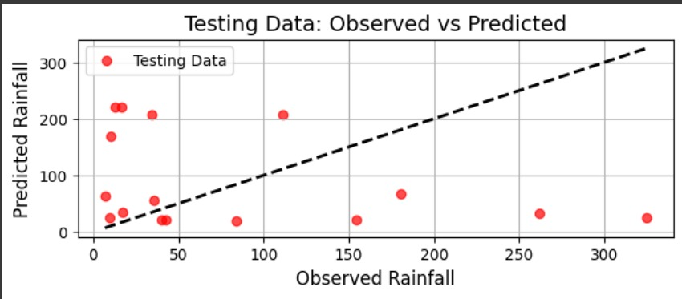

**Figure 16. Scatter Plot – Testing Data: Observed vs. Predicted Rainfall**

During testing, the PSO-RF model demonstrates reduced predictive strength. The scatter points show a wider spread from the ideal diagonal line, particularly underestimating rainfall for values above 150 mm. This indicates reduced generalization to unseen data and suggests that while the model captures moderate rainfall well, it struggles with extremes during testing, which reflects in the increased RMSE and lower correlation during this phase**.**

1. **Time Series Comparison of Pso**

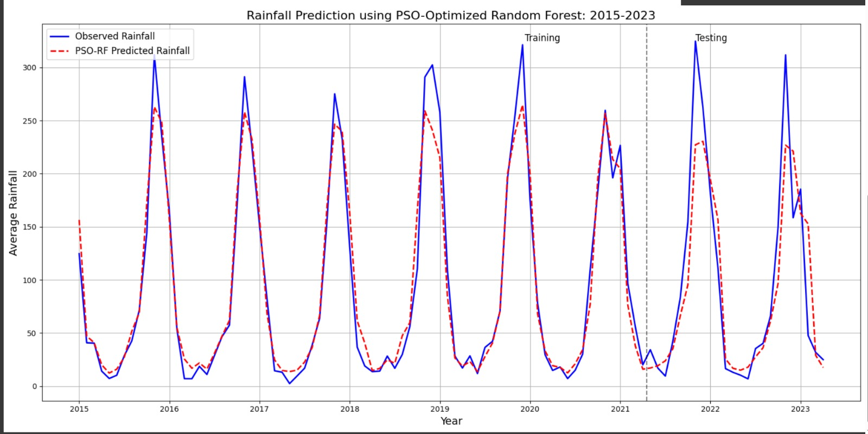

**Figure 17 . Time Series Comparison of Pso**

The time series comparison graph (Figure 17) shows the observed and predicted annual rainfall values across the training and testing periods. In the training period, the PSO model captures seasonal patterns well, but in the test period, larger deviations can be observed, especially in extreme rainfall years. The model is able to follow the general trend of the rainfall but shows limitations in accurately predicting peak intensities during high-rainfall events.

1. **PSO Convergence**

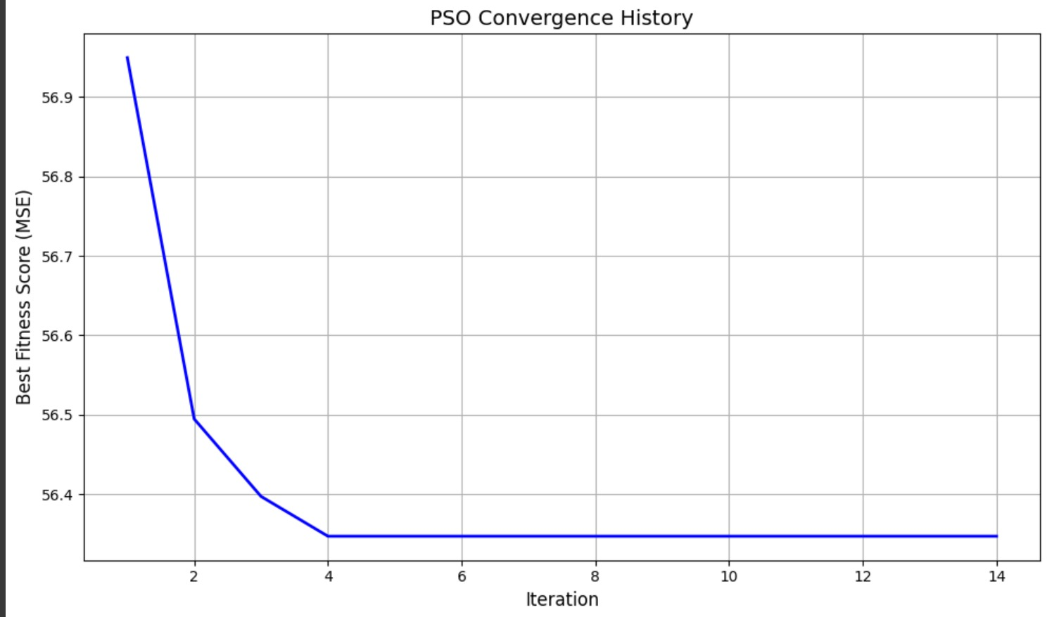

**Figure 18. Pso Convergence**

The **PSO convergence graph (Figure 18)** reflects the optimization process during model training. It demonstrates that the model's error decreased steadily over iterations, eventually stabilizing at a low value, which indicates successful convergence of the PSO algorithm. However, despite the successful training convergence, the drop in test performance suggests possible overfitting or limited generalization to new data.

1. **Map Visualizations of Climate Predictions**

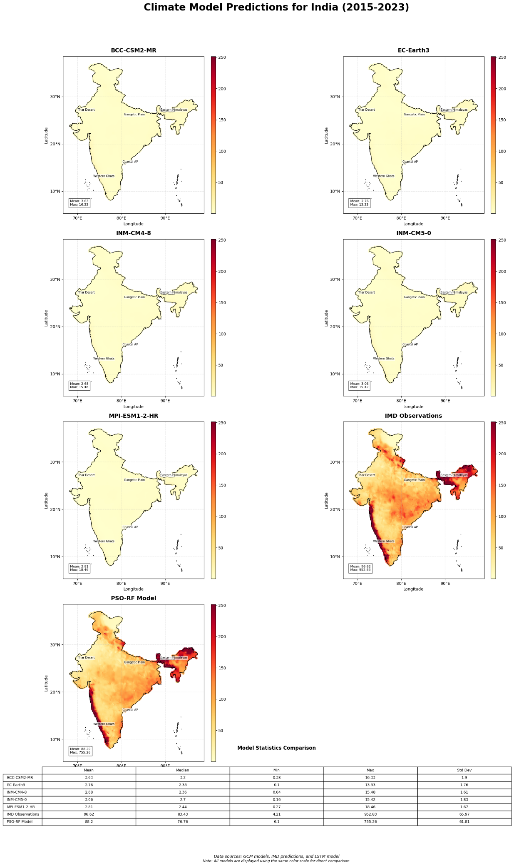 **Figure 19.** **Map Visualization of Climate Predictions**

1. **Intuitionistic Fuzzy Evaluation**

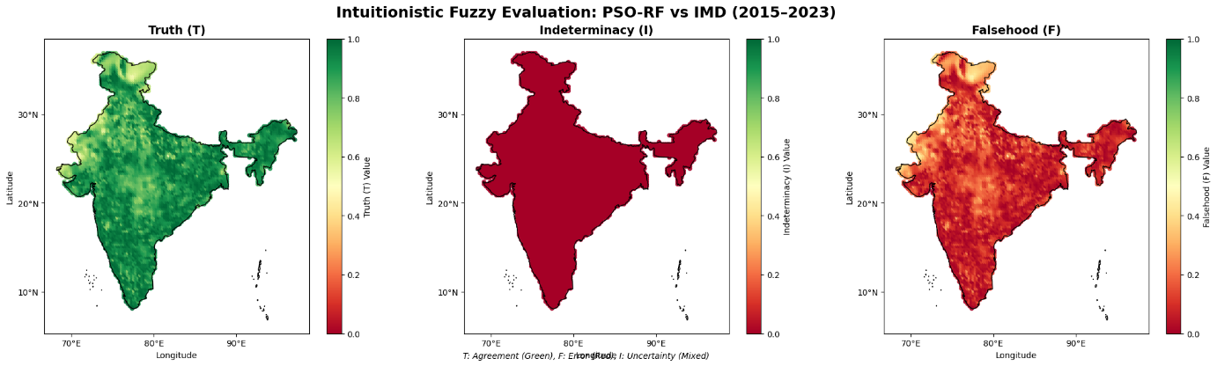

**Figure 20. Intuitionistic Fuzzy Evaluation – PSO-RF vs IMD (2015–2023)**

Spatial evaluation of PSO-RF predictions against IMD observations using Intuitionistic Fuzzy Logic – depicting agreement (T), uncertainty (I), and disagreement (F) values.

The fuzzy evaluation map shows moderate to high agreement (Truth, T) in central and northern India, with scattered lower values in the western and coastal regions. The Indeterminacy (I) map shows near-zero uncertainty across most regions, suggesting consistent prediction behavior. The Falsehood (F) map highlights higher disagreement in eastern and southern coastal regions, indicating areas where the PSO-RF model predictions diverge more significantly from IMD observations. This reveals that while the PSO-RF model generally aligns well, it still faces challenges in capturing local rainfall dynamics in climatically complex zones.

**CHAPTER 7**

**Conclusion and Future Scope**

## Conclusion

This study focuses on enhancing the accuracy and reliability of regional rainfall prediction in India by evaluating two independent modeling approaches: **Long Short-Term Memory (LSTM)** and a **Particle Swarm Optimization-based Random Forest (PSO-RF)** ensemble model. Given the challenges associated with the coarse resolution and bias of individual Global Climate Models (GCMs), this research integrates **GCM outputs with IMD observations** and evaluates model performance using conventional metrics and **neutrosophic logic** (Truth, Indeterminacy, and Falsehood).

The **LSTM model** demonstrated strong performance in capturing temporal patterns of rainfall, exhibiting high correlation, low RMSE, and reliable generalization during the test phase. It also effectively reproduced seasonal behavior and rainfall anomalies, highlighting its ability to learn long-term dependencies. In contrast, the **PSO-RF model** showed improved **spatial representation** of rainfall, outperforming individual GCMs in aligning with the IMD-observed spatial distribution. However, its predictive performance on unseen temporal data was comparatively weaker, as reflected in the higher test RMSE and reduced correlation.

The **neutrosophic evaluation** allowed for a transparent assessment of model alignment with observed data. While both models showed useful agreement patterns, the LSTM approach consistently offered lower indeterminacy and falsehood in the prediction of rainfall intensity and variability.

Overall, this work provides a robust framework for evaluating and comparing rainfall prediction models through a dual lens of **statistical accuracy** and **neutrosophic interpretability**, helping advance region-specific climate risk analysis.

## Future Scope

1. **Development of a Probabilistic Forecasting System**

Future work can incorporate Bayesian deep learning or ensemble-based uncertainty quantification methods to provide confidence intervals alongside deterministic forecasts, making the models more practical for decision-making in disaster management and agriculture.

1. **Hybrid Architecture Expansion**

Combining ConvLSTM, GRU, or Attention-based Transformers with the current LSTM model can further enhance spatiotemporal learning, especially in capturing localized extreme events and sharp seasonal transitions.

1. **Incorporation of Auxiliary Climate Variables**

Incorporating additional predictors such as sea surface temperature (SST) anomalies, ENSO/IOD indices, or soil moisture data can boost model robustness, especially for early-season monsoon forecasting.

1. **Real-time Operational Forecasting Tool**

With further development, this framework could be adapted into a cloud-based forecasting tool integrated with IMD or other meteorological services for real-time rainfall forecasting and anomaly alerts.

1. **Model Explainability and Interpretability**

Leveraging Explainable AI (XAI) tools, such as SHAP or LIME, on both LSTM and PSO-RF outputs could enhance user trust and make the models more accessible to climate researchers and policy-makers.

1. **Transferability Across Regions**

The proposed methodology can be transferred and tested in other climate-sensitive regions such as Southeast Asia, sub-Saharan Africa, or South America, validating the robustness of the TIF-based ensemble strategy in different environmental contexts.

**BIBLIOGRAPHY**

[1] Thant, A. A., & Aye, W. W. (2019). Future Predictions of Rainfall Using GCMs: A Case Study for Mandalay, Myanmar.<https://scispace.com/papers/future-predictions-of-rainfall-using-gcms-a-case-study-for-3yfveq7xsl>

[2] Kumar, V., & Singh, D. (2023). A Spatiotemporal Assessment of the Precipitation Variability Using Bayesian Model Averaged Ensembles for Bihar, India.<https://scispace.com/papers/a-spatiotemporal-assessment-of-the-precipitation-variability-1v052ab7ne>

[3] Improving Projection of Deep Learning-Based Precipitation in India Using Dimensionality Reduction Technique.<https://scispace.com/papers/improving-projection-of-deep-learning-based-precipitation-in-yucao8nw>

[4] Yoo, C., & Cho, E. (2018). Comparison of GCM Precipitation Predictions with Their RMSEs and Pattern Correlation Coefficients. Water.<https://scispace.com/papers/comparison-of-gcm-precipitation-predictions-with-their-rmses-1mh1z2sutm>

[5] Multi-Model Ensemble Approach for Climate Projections in the Mediterranean Region. (2022)<https://www.nature.com/articles/s41598-022-08786-w>

[6] Assessing GCM Convergence for India Using the Variable Convergence Score (VCS).<https://scispace.com/papers/assessing-gcm-convergence-for-india-using-the-variable-4iedx6mnao>

[7] Statistical Downscaling of High-Resolution Precipitation in India Using ConvLSTM Networks. [(2022) https://scispace.com/papers/statistical-downscaling-of-high-resolution-precipitation-in-40duu4lhyy](https://scispace.com/papers/statistical-downscaling-of-high-resolution-precipitation-in-40duu4lhyy)

[8] Nair, A., Singh, G., & Mohanty, U. C. (2018). Prediction of Monthly Summer Monsoon Rainfall Using Global Climate Models Through Artificial Neural Network Technique. Pure and Applied Geophysics.

<https://doi.org/10.1007/S00024-017-1652-5>

[9] Singh, D., Gupta, R., & Jain, S. K. (2016). GCMs Derived Projection of Precipitation and Analysis of Spatio-Temporal Variation over N-W Himalayan Region.<https://scispace.com/papers/gcms-derived-projection-of-precipitation-and-analysis-of-nkgtau4zfe>

[10] Chulsang, Y., & Eunsaem, C. (2018). Comparison of CMIP5 Climate Models in Simulating Precipitation Patterns Using RMSE and Correlation. Water.<https://scispace.com/papers/comparison-of-gcm-precipitation-predictions-with-their-rmses-1mh1z2sutm>

[11] Manfouo, N. C. F., Potgieter, L., & Watson, A. (2023). A Comparison of the Statistical Downscaling and Long Short-Term Memory Artificial Neural Network Models for Long-Term Temperature and Precipitations Forecasting.<https://scispace.com/papers/a-comparison-of-the-statistical-downscaling-and-long-short-2xlflkmy>

[12] Singh, D., et al. (2016). Climate Change Effects on Spatiotemporal Distribution of Precipitation over West Central India: A Statistical Downscaling Approach. Environmental Research, Engineering and Management.<https://scispace.com/papers/climate-change-effects-on-spatiotemporal-distribution-of-3i1jl6yuuivg>

[13] Yuval, J., Langmore, I., & Kochkov, D. (2024). Neural General Circulation Models Optimized to Predict Satellite-Based Precipitation Observations.<https://scispace.com/papers/neural-general-circulation-models-optimized-to-predict-4mh3ayzuztfn>

[14] Saranya, M. S., & Vinish, V. N. (2023). Prioritization of CMIP5 Based Climate Models in Simulating Precipitation Using Multi-Criteria Decision Making Methods.<https://scispace.com/papers/prioritization-of-cmip5-based-climate-models-in-simulating-1jmnjsile6>

[15] Gouda, K. C., Nahak, S., et al. (2018). Evaluation of a GCM in Seasonal Forecasting of Extreme Rainfall Events over Continental India. Weather and Climate Extremes.<https://doi.org/10.1016/J.WACE.2018.05.001>

**Appendix (Any additional Information regarding Project)**

|  |  |  |  |  |  |  |
| --- | --- | --- | --- | --- | --- | --- |
| **Layer No.** | **Layer Name** | **Type** | **Input Shape** | **Output Shape** | **Activation** | **Notes** |
| 1 | rainfall_input | Input | (8, n_features) | (8, n_features) | – | Input sequence for observed rainfall |
| 2 | gcm_input | Input | (8, n_features) | (8, n_features) | – | Input sequence for GCM-predicted rainfall |
| 3 | seasonal_input | Input | (8, n_seasonal_features) | (8, n_seasonal_features) | – | Input sequence for seasonal features |
| 4 | BiLSTM_1 | Bidirectional LSTM | (8, n_features) | (8, 384) | – | 192 units per direction; L1-L2 regularization |
| 5 | BatchNorm_1 | BatchNormalization | (8, 384) | (8, 384) | – | Applied to BiLSTM output |
| 6 | Dropout_1 | Dropout | (8, 384) | (8, 384) | – | Dropout rate: 0.3 |
| 7 | BiLSTM_2 | Bidirectional LSTM | (8, 384) | (8, 192) | – | 96 units per direction |
| 8 | BatchNorm_2 | BatchNormalization | (8, 192) | (8, 192) | – | – |
| 9 | Attention_1 | Custom Attention Layer | (8, 192) | (192) | tanh/softmax | Applies attention to rainfall LSTM output |
| 10 | LSTM_GCM | LSTM | (8, n_features) | (8, 128) | – | Processes GCM input |
| 11 | BatchNorm_3 | BatchNormalization | (8, 128) | (8, 128) | – | – |
| 12 | Dropout_2 | Dropout | (8, 128) | (8, 128) | – | Dropout rate: 0.25 |
| 13 | Attention_2 | Custom Attention Layer | (8, 128) | (128) | tanh/softmax | Applies attention to GCM LSTM output |
| 14 | LSTM_Seasonal | LSTM | (8, n_seasonal_features) | (32) | – | LSTM for seasonal data (no return sequences) |
| 15 | BatchNorm_4 | BatchNormalization | (32) | (32) | – | – |
| 16 | Concatenate_1 | Concatenate | [(192), (128), (32)] | (352) | – | Combines attention outputs and seasonal features |
| 17 | Dense_1 | Dense | (352) | (256) | ReLU | – |
| 18 | BatchNorm_5 | BatchNormalization | (256) | (256) | – | – |
| 19 | Dropout_3 | Dropout | (256) | (256) | – | Dropout rate: 0.3 |
| 20 | Dense_2 | Dense | (256) | (128) | ReLU | – |
| 21 | BatchNorm_6 | BatchNormalization | (128) | (128) | – | – |
| 22 | Dropout_4 | Dropout | (128) | (128) | – | Dropout rate: 0.2 |
| 23 | Dense_3 | Dense | (128) | (128) | ReLU | – |
| 24 | BatchNorm_7 | BatchNormalization | (128) | (128) | – | – |
| 25 | Dropout_5 | Dropout | (128) | (128) | – | Dropout rate: 0.2 |
| 26 | Residual_Concat | Concatenate | [(256), (128)] | (384) | – | Residual connection |
| 27 | Dense_4 | Dense | (384) | (192) | ReLU | – |
| 28 | BatchNorm_8 | BatchNormalization | (192) | (192) | – | – |
| 29 | Dropout_6 | Dropout | (192) | (192) | – | Dropout rate: 0.2 |
| 30 | Output | Dense | (192) | (n_features) | Linear | Final output layer for regression |